Basic message level choreography
The basic scenario from the perspective of the Sender is as follows:
- The Sender transmits Attachment Message to DTCC (#1 in diagram)
- The Sender receives a Response from DTCC indicating if the Attachment Message has either passed or failed DTCC validation. (#1a in diagram)
- The Sender receives a Recipient Reject/Accept from DTCC indicating if the Attachment Message was or was not successfully delivered to and accepted by the Receiver and returns a response to DTCC (#3 and #3a in diagram)

The basic scenario from the perspective of the recipient is as follows:
- The recipient receives Attachment Message from DTCC, performs auto-detectable validation edits on the message, and returns a Recipient Reject/Accept response to DTCC (#2 and #2a in diagram)
- The recipient receives a Request message from DTCC if the Reject/Accept SOAP Response did not pass DTCC validation and returns a response to DTCC (#4 and #4a in diagram)

Here is the basic choreography of sending an Attachment Message

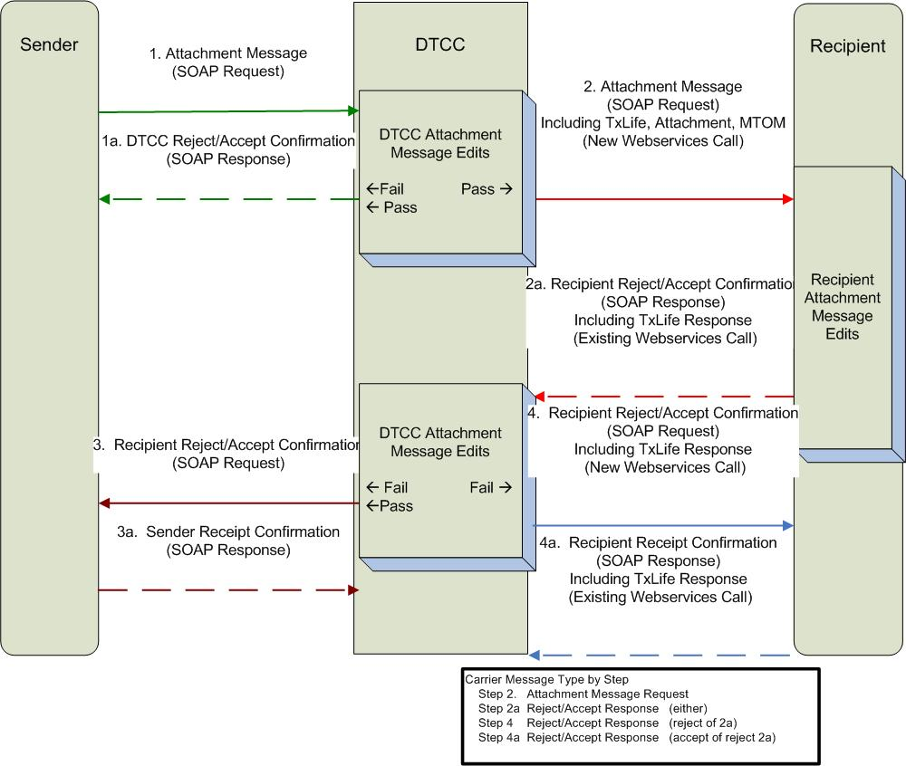

Requirements and Restrictions
To ensure proper implementation, all parties involved in the messaging logic must adhere to the specified messaging guidelines.

- DTCC Attachment participants must have the capability to both send and receive messages to and from DTCC via web services.

- For Pilot, an attachment transmittal is strictly concerned about the sending of an attachment from a Sender to the receiver, over the DTCC channel. It precludes the scenario where the receiver initiates an attachment request, although it is probable for future enhancement.

- An automatic re-transmittal request due to a reject, is not allowed in this implementation because the re-transmittal request is highly dependent on the attachment business scenario, reject reason, and message type.

- For an attachment that pertains to another DTCC message, the order of arrival of either the associated DTCC message or the attachment message(s) should not be used to determine the validity of attachment messages, for good reasons. For example, if the related IPS message has not arrived by n days, it is up to the business process (e.g., application, replacement, etc.) to reject the request. Such rule should not be reinforced by the attachment logic. N would be determined by individual firm.

- Firms will be required to use MTOM to send the attachments. Inline attachments will NOT be permitted though DTCC.

MTOM is the W3C Message Transmission Optimization Mechanism, a method of efficiently sending binary data to and from web services. It uses XOP (XML-binary Optimized Packaging) to transmit binary data and is intended to replace both MIME and DIME (DIME is a lightweight, binary message format that can be used to encapsulate one or more application-defined payloads of arbitrary type and size into a single message construct) attachments. At the very beginning of web services people thought of sending text data with SOAP messages. But after some time people thought of sending binary files as a SOAP request or sending a sound clip as a web service request. So as a solution to these problems MTOM came into the act.

http://www.w3.org/TR/soap12-mtom/

Message Types
As described in the sequence diagram, three types of message are necessary to ensure the delivery of attachment messages over TCP/IP connections:

- Attachment Request Message
- Reject/Accept Response
  - DTCC
  - Recipient
- Recipient Reject/Accept Confirmation Request

Attachment Message
An Attachment message (Steps 1 and 2) contains one or more Forms Instance objects each representing one attachment. It flows from the Sender to the intended recipient. The ACORD TXLifeRequest message format for TransType code 510 has been adopted for this purpose.

Reject/Accept Response
When a message is submitted to another party, a SOAP response is returned to reflect the submission result (e.g., Sent/Received/Failed/Rejected). This is equivalent to the return code of a web service call between the participants. The standard TXLifeResponse construct will meet this need.

A Reject/Accept message contains receipt and acceptance results for the Attachment message and is sent by DTCC or the attachment recipient

DTCC (Step 1a)

Scenario in the Sequence Diagram | ResultCode | ResultInfo  Code | ResultInfoCode Description
Step 1a – Attachment message was accepted (successful) | 1 | Not Used
Step 1a Attachment was rejected (failure) | 5 | 200 | DTCC System Validation Error (only used by DTCC)
Step 1a – Attachment message was rejected (failure) | 5 | 103 | DTCC does not support the Mime Type
Step 1a – Attachment message was rejected (failure) | 5 | 104 | DTCC does not support the AttachmentType code
Step 1a – Attachment message was rejected (failure) | 5 | 2003 | Document Control Number is invalid (i.e. missing for 103 TransType)  Required element missing  Include resultinfodescription with name of the element.

Recipient (Step 2a)

Scenario in the Sequence Diagram | ResultCode | ResultInfo  Code | ResultInfoCode Description
Step 2a – Attachment message was accepted (successful) | 1 | Not Used
Step 2a – Attachment message was rejected (failure) | 5 | 100 | General Error – used for any reject that does not have a specific error code assigned.
Step 2a – Attachment message was rejected (failure) | 5 | 203 | The request contains a transaction type that the receiver does not process
Step 2a – Attachment message was rejected (failure) | 5 | 114 | The receiver does not accept attachments from this Sender.
Step 2a – Attachment message was rejected (failure) | 5 | 107 | The receiver does not support the Mime Type. For instance the receiver may accept PDF but not TIF, therefore they can reject on TIF
Step 2a – Attachment message was rejected (failure) | 5 | 106 | The receiver does not support the AttachmentType code
Step 2a – Attachment message was rejected (failure) | 5 | 113 | Document is not expected based on the OriginatingTransType
Step 2a – Attachment message was rejected (failure) | 5 | 2044 | Duplicate of a previous transaction. . Based on DocumentControlNumber or TransRefGUID

Other Codes:

Scenario in the Sequence Diagram | ResultCode | ResultInfo  Code | ResultInfoCode Description
Step 2a – Attachment message was rejected (failure) | 5 | 105 | Unable to decode the transaction – Out of scope
Step 2a – Attachment message was rejected (failure) | 5 | ? | Follow-up attachment message does not have the same originating TransType – Out of scope for pilot (Issue list)
Step 2a – Attachment message was rejected (failure) | 5 | 2002 | Duplicate Object Found. For instance two Application documents on the same attachment message – Out of scope
Step 2a – Attachment message was rejected (failure) | 5 | 115 | Hash Code Mismatch  Carrier validates Hash code and it does validate properly.
Step 2a – Attachment message was rejected (failure) | 5 | 300 | System Unavailable

Recipient Reject/Accept Confirmation Request
A Confirmation Request is a new transmittal message (SOAP Request) with a TXLifeResponse Payload. This message will used to update the Sender of the Reject/Accept status of the original Attachment message. This corresponds to Step 3 on the diagram. If the original Reject/Accept Response (Step 2a) failed DTCC validation this message will also be sent to the recipient. This is Step 4 on the diagram

Security

Transport via DTCC SMART Network
All companies using this functionality will be participants of DTCC. DTCC provides each participant with communications infrastructure through the SMART network. The SMART network will provide for router level encryption. (For more information on the SMART network, see the “Complete Guide to SMART” document).

http://www.dtcc.com/products/documentation/technology/SMART%20user%20guide.pdf

Message level security – not in scope for phase 2

Currently, MLS is only available for the Fund Transfers product. See Message Level Security Technical guide for Fund Transfers for detailed information.

Data Hash Algorithm

As part of Attachment message, the send is required to include a hash algorithm using Secure Hash Algorithm 1 (SHA-1). The Hash elements are located in the Attachment aggregate (see 2.5.6). The Hash will verify the attachment content against data corruption independent of the file type (PDF, TIF).

Message Control Table
Each message will have a standard format with a sub transaction code to indicate the business event the attached information is intended to support. To enable companies to implement independent business functionality and not be required to support or reject each type of business event, DTCC will create a control table. The table will enable each participant to authorize the type of business events that they wish to receive. DTCC will validate and reject if necessary any business event not indicated on the table.
Once authorized to receive a business event, all trading relationships may submit that transaction to the receiving participant.

DTCC will create a control table similar to one being used in the L&A Access web-based functionality. There will be a screen for both Test and Production

Defined Data Points for Control Table Requirements:

- Participant NSCC ID = (can we do this at a family level)

  - Business Process/Message type = “510” - Value doesn’t change for this purpose.

    - Originating Transaction type = (ex “103” = New Business)
      - Originating SubTransactoin Type – not available at this time
      - Mime Type - Select one or more from the current list of MIME types supported for this availability.

      - Message Level Security – Phase 2 = Provide a list to define what is supported

      - Trading Partner Info (NSCC Id) – currently available
        - Dates:- not available at this time
        - Start date – May be future-dated
        - End date - Used to terminate the availability

Screen shots

Portal/Application Login

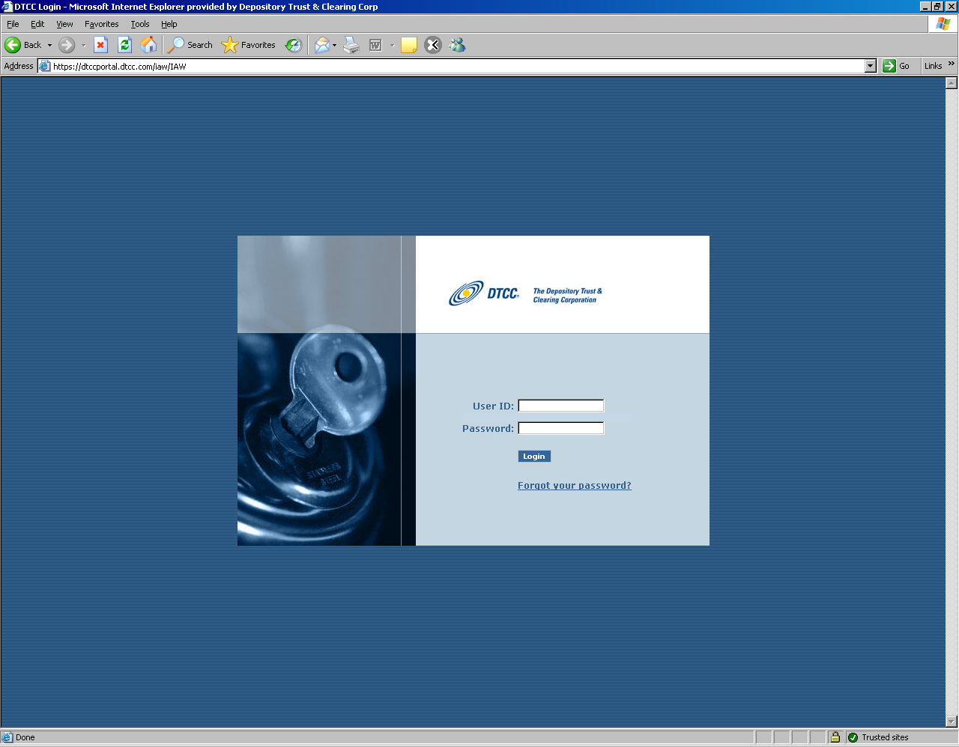
Select Tag screen – This is optional screen, if user has multiple participant numbers this will appear

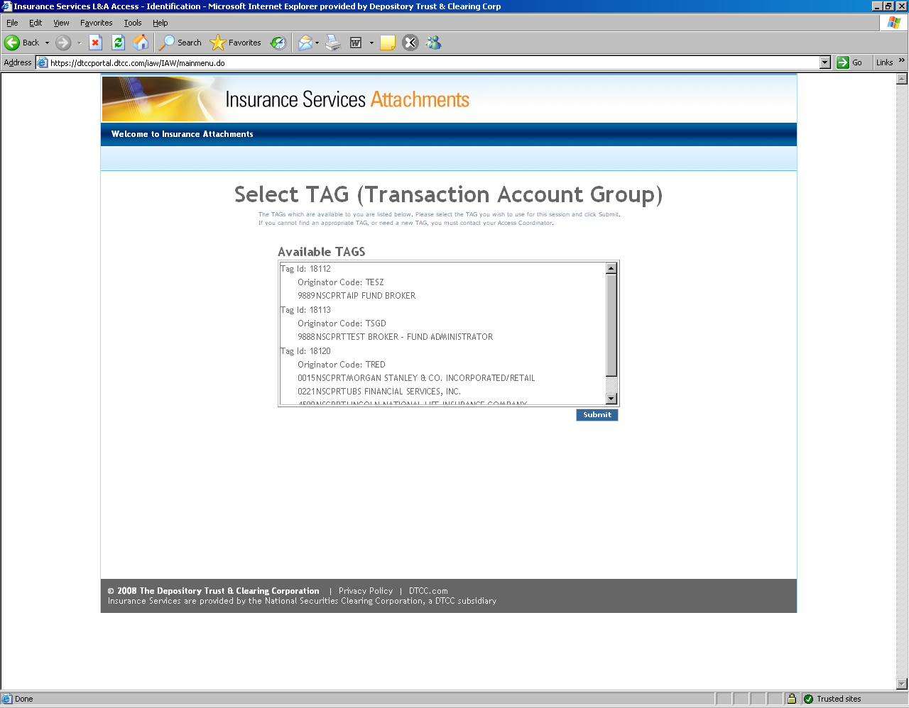

Select Participant – Drop down if user has multiple ids or non editable if has only one

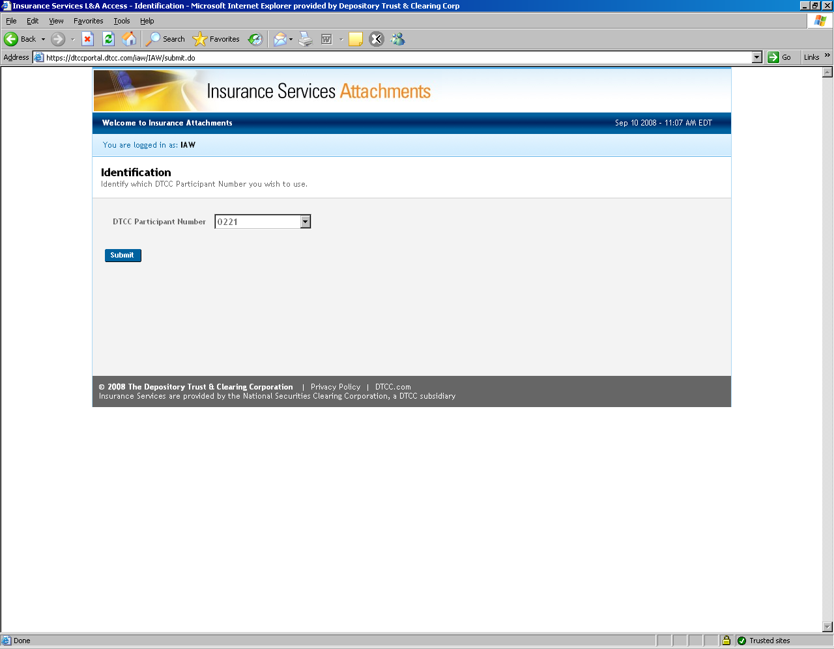

Message Details

ACORD Insurance Standards
The message defined in this implementation guide is based on the ACORD Life and Annuity Standards. ACORD provides an open insurance industry XML vocabulary which defines a common, consistent view of insurance information. All messages herein are based on the ACORD Life Standards Data Model. This means every message regardless of Sender and/or receiver (or systems) and regardless of process all share a consistent means of describing like data – a Policy is always a Policy and is always formatted and defined the same. This consistency reduces translation effort (and errors) and insures that all participants in the insurance value chain can share a common understanding as well as view of insurance data.
For more information contact ACORD at Life@acord.org. The public standards are available on their website at www.acord.org.

Attachment Message Principles
The following basic premises apply all the Attachment messages.
- Message is based on ACORD’s Version 2.20.00.
- Real time message response is expected.
- DTCC will provide XML Schemas (XSD’s) for this message. These schemas serve two purposes, first allowing creators of these messages to validate their work against the schemas and second as the production reference from which DTCC will validate these XML messages passing through the DTCC IPS network.
- Several of the identifiers on objects, including the principle one identifying the message itself TXLife/TransRefGUID, all call for a Globally Unique Identifier (GUID) or UUID. This is a large string which is programmatically generated and virtually guaranteed to always be unique.
- Every Request message must have its own GUID. Every Response message, if applicable, MUST return the TrasnRefGUID of the original Request message.
- One or more attachment documents must be included within an attachment message.
- Each attachment message must be for a single recipient.
- Each attachment message must relate to single discreet business event.
- DTCC supports two MIME types (PDF or TIFF). It is up to the trading partners to determine the acceptable MIME type to be used. Note: There are various types of PDF formats that may need to be supported such as File-PDF, Image-PDF, Application-PDF. This needs to be confirmed with trading partners.
- Multiple documents may be imaged and transmitted as a single attachment object (glob). It is up to trading partner on how they image and transmit or receive and unbundled globed documents.
- For non-esign submission, there are cases in which a receiving firm may receive multiple forminstance in a single message.
  - Ex – Agent faxes documents in two steps which causes to form instance objects, system related fax errors, corrections to original documents.

Use of Type Codes
Wherever possible, the ACORD Data Model uses lookup codes or tables, what they refer to as typecodes as the data type for elements of the model. These are much easier to process than strings. They are easy to identify as attributes on each XML Tag, like this: <TransType tc=”103”>New Business</TransType>. The ‘tc’ attribute is always on every typecoded element and that is the value you should reference and use when processing the message. The text between the tags, in the case of type code values, is optional and should NOT be processed.
Through this specification we will clarify which typecode values are relevant to the messages here.

ACORD XML Message Structure Overview
The ACORD Life and Annuity Standards are built first on a common data model. All specific insurance business processes, AKA messages, are then defined using the life data model, with only those elements necessary are used. All messages however will always define a given element in the same way, thus promoting reuse, consistency and a common vocabulary for describing insurance concepts. When looking at only a specific message the design of the message may seem un-optimal, and indeed it most likely is. This is due to the greater objective of always having insurance concepts modeled in the same consistent method regardless of process or message.

Basic Message Construct
Every message begins with a message or transaction ‘header’. It defines the transaction type and transaction level information like date & time, etc. Its’ basic form is…
TXLife
TXLifeRequest (created by Sender)
OLifE (specific message business data)

And then the response comes back as…
TXLife
TXLifeResponse
TransResult ← Location of success or failure and details
ResultInfo

Each message then has a specific set of expected business data to accompany or be returned in a request or response message. The basic form for the messages here (a subset of the overall ACORD Life Data Model) is…

For an Attachment we simply append the attached data as follows, in line, with where the attachment is relevant or applies. This mimics the pattern for all ACORD msgs (with or without an attachment, for reuse and consistency).
TXLife
TXLifeRequest
… Transaction Details
OLifE
Holding (or <Party> or <FormInstance>)
Attachment
… Attachment details
Party : Sending Party
Party : Receiving Party
Relation : Associate Sender with Primary Message Object (e.g Holding, Party of FormInstance)
Relation : Associate Receiver with Primary Message Object (e.g Holding, Party of FormInstance)

Attachment Structure Details
Table Legend:
DTCC Element: Basic name of field
ACORD Element: actual name of data element in the ACORD schema.
DTCC Validates: “Y” = Yes DTCC edits/validates, “N” or blank they do not
Use: “R” = Required, must be provided, “C”=Conditional with the condition when it’s required defined. If a notation (ex R) is indicated. This is a reference to the ACORD Testing Certification Facility (SEE SECTION 3). This references the type of error that would occur in the testing facility is the rule is not followed.
In the ACORD Element section are two specific description notations. The first sentence is the parent object and property or attribute where the information is stored.
Type: “A” = Aggregate or container object, “B=Boolean, “S” = String, “D” = Date, “T” = Time, “C” = Currency Amount.

The DTCC will validate the following:
- Specified field formats are followed
- Required fields are present
- Other specific DTCC validations defined in the definition section

TXLifeRequest/TXLifeResponse Aggregate

TXLife Request is used by Sender (Distributor). TXLife Response is used by Recipient (Carrier) to provide result.
Definition | ACORD Element | DTCC Validate | Use | Type
Pointer to the principal object where the Attachment data object <Attachment>can be found.  Must point to the FormInstance object ID.  For e-signed documents, the @PrimaryObjectID will point to the form instance for the document manifest, if one is available. This will tell the programmer where to begin parsing the documents. For hybrid documents where there may not be a separate document manifest, the @PrimaryObjectID will point to the first form instance that contains the scanned documents. | @PrimaryObjectID | Y | R | IDREF
Transaction Reference Guid  Unique Identifier for this message.  Used later in the response (if sent) to link the response with the original request.  GUID in response must match GUID from request. | <TransRefGUID> | Y | R | GUID
Business Process / Message Type  510 = Forms Instance (Attachment) | <TransType tc=”#”> 510 | Y | R | Type Code
The TransSubType further defines the TransType of 510 into an attachment message. This element is required if message is sent in accordance with NAVA STP.  NAVA e-docs specifies TransSubType tc="1022500300">Attachment </TransSubType>.  This is required for 2.20 schema validation.  This field should be optional. If the Carriers are sending the attachment in accordance with the edoc specific NAVA implementation, then the code above should be sent. Otherwise, this element may be excluded. | <TransSubType tc="1022500300">Attachment </TransSubType> - | Y | O | Type Code
For TXLife Request - Date Message was created.  For TXLife Response – Date Message was responded to  The standard date will be yyyy-mm-dd date. Example: 2008-04-24 | <TransExeDate> | Y | R | Date
Time Message was created. Attachments will utilize the GMT offset with the NY time being the base; so, the offset will be either -4 or -5. The time format will be 20:49:01-04:00 . | <TransExeTime> | Y | R | Time
Test Indicator  0 = False (Production)  1 = True (Test) | <TestIndicator tc=”#”> | Y | R | Boolean
Indicator of what the object type is that the PrimaryObjectID is pointing to, so receiving system easily knows what to expect.  Only expected Value:  101- Form Instance | <PrimaryObjectType tc=”101”>Object Type | Y | R for TXLife Request  Not Used for TXLifeRespons | Type Code
Correlation Identifier– to be used to relate multiple attachment messages. This will only be used in Phase II implementation. | <CorrelationGUID/> |  | O for TXLife Request  Should be passed back on TXLifeResponse if received. | GUID
Specifies the state of the CorrelationGUID.  1 - Initial  2- Ongoing  3 - Final | <CorrelationGUIDState tc=""/> |  | C  Req if CorrGuid present | Type Code
Container object for the business message details | <OLifE> | Y | R for TXLife Request  Not used for TXLife Response

TransResult – Required in TXLife Response (Carrier) only. Not used for TXLifeRequest
Definition | ACORD Element | DTCC Validate | Use | Type
 | <TransResult> | Y | R | Object
Result Code  1 = Success  5 = Failure | <ResultCode tc=#”> | Y | R | Type Code
Result Details – Only applicable if an error. | <ResultInfo> | C | C  If 5 (failure), then required  If 1, not used. | Object
Detail code defining error  See code list Section 1.11  DTCC will use code 200 for validation errors. Firms will not be allowed to use this resultinfocode for their own use.  Carrier would be allowed to use 100, 203, 114, 107, 106, 113, 115, 300, 2044, only | <ResultInfoCode tc=”#”> | Y | R | Type Code
Description of the issue/error. May clarify or expand upon the code meaning potentially with instructions how to remedy or what to do to fix.  This is only expected in cases where the code is not clear. Please refer to the ResultInfoCode list below. | <ResultInfoDesc> | Y | C  Req for ResultInfo Code = 2003 | String
Used by DTCC only  DTCC will use this field on edit rejects to indicate DTCC reject reason.  Example – Invalid TransRefGuid | <ResultInfoSysMessageCode> |  | DTCC Only | String

Holding Aggregate – Optional on TXLifeRequest, Not Used on TXLifeResponse
Holding is conditional based on originating transaction type. Expected for New Business (@CarrierPartyID and CusipNum)

Definition | ACORD Element | DTCC Validate | Use | Type
Unique Identifier for the Holding | @id | Y | R | IDREF
 | <Policy> |  | R | Object
 | @CarrierPartyID |  | R | ID
It was noted by the WG that the PolicyNumber may not be known (as with New Business). If it is blank, the Holding aggregate should still be sent with Cusip and CarrierPartyId. | <PolNumber> |  | O | String
CUSIP Number – product cusip  Starting on September 24, 2009, DTCC will require CUSIP to be included when OriginatingTransType = 103 (New Business)  CUSIP will be validated against the DTCC CUSIP profile. Any cusip not in the profile will be rejected back to the submitter. | <CusipNum> |  | C  Will change to Conditional starting in Sept 09 | String

Party Aggregate – Organization – Required for TXLifeRequest, Not Used on TXLifeResponse
Must have a minimum of two Party>Organization Aggregates for TXLifeRequest. One for Sender and one for recipient. DTCC needs the DTCC member code for each organization to the message.

 | ACORD Element | DTCC Validate | Use | Type
Unique Identifier for the Party | <Party @id> | Y | R | ID
Indicates whether the party being described is a person or an organization  2 = Organization | <PartyTypeCode tc=’2’> | Y | R | Type Code
Legal name of the organization | <FullName> | Y | R | String
Detail about the Organization | <Organization> | Y | R | Object
DTCC Participant number | <DTCCMemberCode> | Y | R | String
Associated Firm Id – used when there is a corresponding firm associated with a DTCC Member organization. DTCC will not validate the value of the OrgCode. | <OrgCode> | Y | O | String

Party Aggregate – Person – Optional for TXLife Request, Not Used on TXLife Response
 | ACORD Element | DTCC Validate | Use | Type
Unique Identifier for the Party | <Party @id> | Y | R | ID
Indicates whether the party being described is a person or an organization  1 = Person | <PartyTypeCode tc=’1’> | Y | R | Type Code
Detail about the Person | <Person> | Y | R | Object
Last Name | <FirstName> | Y | R | String
First Name | <LastName> | Y | R | String

FormInstance Aggregate – Required on TXLifeRequest, Not Used on TXLifeResponse
There will be no more than one attachment object associated with each form instance. – need to document how we will embed the detail from the document manifest.

Definition | ACORD Element | DTCC Validate | Use | Type
Unique Identifier | FormInstance @id | Y | R | ID
ProviderPartyID  - should be the Sender. This is needed to relate the FormInstance to the Sending Party. | ProviderPartyID @id | Y | R | ID
ReceiverPartyID  - should be the Recipient. This is needed to relate the FormsInstance to the Receiving Party  Need MR to add to FormsInstance for 2.20 | ReceiverPartyID @id | Y | R | ID
Form Name | <FormName> | Y | O | String
Provider Form Number – for document manifest | <ProviderFormNumber> | Y | O | String
DocumentControlNumber. Provides a unique identifier for the forms that are attached to the message. There is a one for one correlation between FormInstance and New Business transaction.  DTCC will edit to ensure that each occurrence of FormsInstance within one TXLife Request has the same document control number.  For None (2) (no electronic message will be sent) – this should be blank element should not be sent | <DocumentControlNumber> | Y | C | String
Document Control Type Qualifier identifies the type of data contained within the Document Control Number  1 – Order Entry Control Number – The control number assigned to the electronic order at the time of order entry (used from DTCC APP paperwork record)  2 – None – There is not a corresponding Document Control Number. This will be used when it is a standalone attachment  This field is required when <DocumentControlNumber> is sent | <DocumentControlType>  OLI_DOCCTRLQUAL_ORDERENTRY  OLI_DOCCTRLQUAL_NONE | Y | C | Type Code
Originating Transaction Type.  This field is used to define the business event that the attachment object is related to.  Available types:  103 – New Business / i.e. DTCC APP File  107 – Arrangement Administration  508 – Sub Payment / i.e. DTCC Sub file  1213 – Financial Activity Transmittal / Confirms  1235 – Holding Statement Transmittal / Statements  181 – Address Change Request  183 – Email Address Change Request  182 – Phone Change Request  186 – Party Update  102 – Fund Transfer  185 – Update Financial Activity  410 – Appointment Request  413 – Appointment Termination  129 – License Request | <OriginatingTransType tc=”###”>  Originating Transaction Type | Y | R | Type Code
Originating Transaction SubType  Not to be used in phase 1 (not needed for new business). Code list needs to be further analyzed.  *Note: Element is part of 2.20 MR. No codes added as part of 2.20 | <OriginatingTransSubType tc=”###”>  Originating Transaction Sub Type  TRANS_SUBTYPE_CODES | Y | O | Type Code
Signature Object | <SignatureInfo> | Y | O
Attachment Object | <Attachment> | Y | R

SignatureInfo Aggregate – Optional on TXLife Request, Not Used on TXLife Response
Definition | ACORD Element | DTCC Validate | Use | Type
Unique ID | <SignatureInfo @id> | Y | R | ID
SignaturePartyID - used to point to party this signature is related to. | FormsInstance.SignatureInfo.SignaturePartyID | Y | R | IDREF
Signature Role  Role code describing signer's relationship to the form. | FormInstance.SignatureInfo.SignatureRoleCode  OLI_LU_PARTICROLE – need to determine exact role codes accepted. | Y | R | TypeCode
Signature Date  On SignatureInfo, documents the date on which the signature party performed the signature.  The standard date will be yyyy-mm-dd date. Example: 2008-04-24 | FormInstance.SignatureInfo.SignatureDate | Y | R | Date
Signature Time  On SignatureInfo, documents the time at which the signature party performed the signature.  SignatureTime will utilize the GMT offset with the NY time being the base; so, the offset will be either -4 or -5. The time format will be 20:49:01-04:00 . | FormInstance.SignatureInfo.SignatureTime | Y | R | Time

Attachment Aggregate – Required on TXLife Request, Not Used on TXLife Response
Definition | ACORD Element | DTCC Validate | Use | Type
Unique ID | <Attachment @id>
Attachment Date | <DateCreated> | Y | R | Date
Attachment Data  This is where the Attachment data is placed in scenarios where document is not attached to this attachment aggregate. Used for document manifest.  Note: AttachmentData64 and AttachmentData are mutually exclusive. Sender must choose on of these data types in the aggregate. Cannot send both. | <AttachmentData> | Y | C  Required if Attachment64 is not used | String (ANYDATA)
Attachment Data Base64Binary  Used for attachments that includes the imaged document constructed via the use of MTOM.  Note: AttachmentData64 and AttachmentData are mutually exclusive. Sender must choose on of these data types in the aggregate. Cannot send both. | <AttachmentData64Binary> | Y | C  Required if AttachmentData element is not used | base64binary
Type of Attachment – Defines what the attachment data is.  Starting on September 24, 2009, DTCC will not validate against the ACORD code list. DTCC will allow any value.  Suggested Code List:  1 – Document – specifics undefined  2 – Comment or note text  5 – Form (generic, actual type unknown) – std form  10 – Original Application – preferred over 5  See also specific form types for ACORD forms, e.g.  73 – ACORD 951 Replacement Form  Codes recommended as part of NAVA STP. These can be used in place of codes listed above.  2550010 Account Opening Form  2550020 Electronic Consent Form – Carrier  2550030 Electronic Consent Form – Distributor  2550040 Variable Annuity Contract Prospectus  2550050 Fund Prospectus  2550060 Variable Annuity Profile  2550070 Fixed Annuity Profile  2550080 Indexed Annuity Profile  2550090 Risk Tolerance Questionnaire  2550100 Privacy Notice  2550110 General VA Disclosure (rule 2821)  2550120 Compensation Disclosure  2550130 Conflicts of Interest Disclosure  2550140 Sales Summary Disclosure  2550150 NAIC Buyers Guide – Fixed | <AttachmentType tc=#>  Attachment Type | Y | R | Type Code
Form
2550160 NAIC Buyers Guide – Variable
2550170 NAIC Buyers Guide – EIA
2550180 NAIC Disclosure – Fixed and EIA
2550190 Annuity Application – NAVA Compliant
2550200 Annuity Application – Non NAVA Compliant
2550210 Trust Document Certificate
2550220 Systematic Withdrawal Form
2550230 Telephone or Electronic Transaction Authorization
2550240 Jumbo Case Review Form
2550250 Tax Disclosure Form – W8
2550260 Tax Disclosure Form – W4P
2550270 Power of Attorney Affidavit
2550280 Rider Reset Authorization Form
2550290 Annuitization Authorization Form
2550300 Interest Sweep Form
2550310 Asset Rebalancing Form
2550320 Dollar Cost Averaging (DCA) Form
2550330 NAIC Model Reg Replacement Form
2550340 Non- NAIC Model Replacement Form
2550350 New York Regulation 60 Disclosure Form
2550360 Exchange/Rollover Transfer Form
2550370 Suitability Determination Form
2550380 Customer Confirmation Form
2550390 Welcome Letter
2550400 Annuity Policy Contract
2550410 Proof of Delivery Statement
2550420 Guaranty Association Notices
2550430 Qualified Plan Disclosures
2550440 Service Forms
2550450 Buyers Guide (Non-NAIC)

Mime Type  The type of attachment that follows.  11 – Image/ TIFF  17 – File/PDF | <MimeTypeTC tc=#>  MIME Type | Y | R | Type Code
The method of encoding the Attachment Data  4 – Base64  This is used for encoding of base64Binary | <TransferEncodingTypeTC tc=”#”>  Transfer Encoding Type | Y | R | Type Code
AttachmentBasicType – is this needed. Was in XML sample but not in data dictionary  1 = Text  3 = File (for binary attachments) – This one will be most commonly used for this product. | <AttachmentBasicType tc="3">File</AttachmentBasicType>
Attachment location – include in the message or a URL to the document  5 – XOP Include | <AttachmentLocation tc=”5”> | Y | R | Type Code
Attachment Hash – The hash result or digest used to verify the attachment content against data corruption independent of the file type (PDF, TIF) | <AttachmentHashValue> | Y | R | String
Attachment Hash Type – The type of data hash algorithm used.  Must be filled with SHA1 if <AttachmentHash>  2 – Secure Hash Algorithm 1  SHA-1 is a hash algorithm that computes a 160-bit, fixed-length digital representation of an input data sequence of any length. | <AttachmentHashType>  OLI_LU_HASH_TYPE_SHA1 | Y | R | TypeCode

Relation Aggregate – Required on TXLife Request, Not Used on TXLife Response

Must have a minimum of two Relation Aggregates for TXLife Request. One for Sender and one for recipient.
 | ACORD Element | DTCC Validate | Use | Type
Relation ID | <Relation @id> | Y | R | ID
OriginatingObjectID  - what is the originating top level object  - FormInstance | <Relation @OriginationObjectID> | Y | R | IDREF
RelatedObjectID  - what is the related object?  - Holding | <Relation @RelatedObjectID> | Y | R | IDREF
Originating Object Type  101 – Form Instance  4 – Holding  6 - Party | <OriginatingObjectType tc=’###”> | Y | R | Type Code
Related Object Type  - What is the pointer to the second party in the association referencing – normally a Party  101 – Form Instance  4 - Holding  6 – Party | <RelatedObjectType tc=’##’> | Y | R | Type Code
Related Role Code  - Defines the type of object being referenced by Originating Object ID to Related Object Type)  tc="83">Broker Dealer</RelationRoleCode> - expected for New Business (Holding to Party relationship)  Example  OriginatingObjectType = 4  RelatedObjectType = 6  105 – AttachedForm – to be used for esign when the document is listed in the FormInstance aggregate (FormInstance to FormInstance relationship)  Example  OriginatingObjectType = 101  RelatedObjectType = 101  106 – Include Form – to be used for hybrid where there is a glob of documents that contain documents in additional occurrences of FormInstance (FormInstance to FormInstance relationship)  Example  OriginatingObjectType = 101  RelatedObjectType = 101 | <RelationRoleCode tc=’###’> | Y | R | Type Code
tc="35">Annuitant</RelationRoleCode> - expected for New Business – used when Person is used under party (Holding to Party relationship)

Example
OriginatingObjectType = 4
RelatedObjectType = 6

tc="8">Owner</RelationRoleCode> - expected for New Business – used when Person is used under party (Holding to Party relationship)

Example
OriginatingObjectType = 4
RelatedObjectType = 6

tc="86">Subordinate Office</RelationRoleCode> - used for Associated firm (Party to Party relationship)

Example
OriginatingObjectType = 6
RelatedObjectType = 6

OriginatingObjectID = The submitting BD is the submitting party; so, the OriginatingObjectID will need to relate to the party id for the submitting BD.

RelatedObjectID = Associated firm is the related object; so, the RelatedObjectID will need to relate to the party id for the associated firm.

