DTCC & EBIX FACT SHEET

Overview
Attachments Service: Attachments Enables distributors and insurance carriers to electronically exchange digitally imaged documentation, signatures, forms and other types of data during the pre-sale, new business and post-issue processing of annuity business.

The attachments transaction was built adopting the ACORD TXLifeRequest message format for the TransType Code 510. It contains one or more Forms Instance Objects each representing one attachment.

Current business lines served: Annuities - Variable /Fixed

Generic Functionality to Support Attachments Service:

- Web Service:
  - Provide web service connection to DTCC to receive attachment messages.
  - Receive and process messages using MTOM compression process.
  - Parse and strip web service message element data.
  - Store message data
- EBIX
  - Supports the PDF format of an attachment
  - Sends the attachment as a webservice , it is not possible to batch
  - The attachment is sent separately from the app file, Carriers are expected to be able to receive attachments before, after, or in conjunction with an app file
  - Sends separate PDF’s (FormsInstance) of e-signed forms, wet signed forms are sent in one forms instance (glob)
- DTCC’s Attachment Access
  - Supports both PDF and TIF
  - Can be used for wet signed applications, and standalones
  - The Document Control ID is manually entered by the individual processor
  - Requires the Carrier have additional logic to build a attachment record (33-44) for the electronic applications received in order to successfully match the Attachment to the App
- APP processing rules
  - Interrogate Attachment to determine course of action required depending on type
    - Stand-alone – Paper work only w/o app data
    - Hybrid – Attachment contains all paperwork as one TIF/PDF
    - STP Compliant – Separate TIF/PDF received for each document
  - DTCC Attachment Access
    - Parameter driven functionality in support of Broker Dealers using Attachments access allowing linking of app data to the attachment
  - Monitors receipt of Attachment and APP
  - Matches Attachment and corresponding APP record either manually or systematically.
  - Update “forms received” If applicable
- DTCC Receiver Control Table:
  - Used by Carriers to set up new Distributors using Attachments service.
  - Ability to control which distributors and what type of Attachments are allowed per distributor.
- ANB E-Signature communication:
  - Provides the ability to recognize E-signed vs. wet signed attachments
  - Must be aligned with an e-Sign vendor. Ebix supports SIGNiX.
- Potential Reporting Required
  - Daily report of attachments received
  - Monthly roll up of all attachments received for month
  - Reports broken down by Distributor and E-signed vs. Non E-signed Attachments
  - Rejected Attachments reporting.

Systems Development “Value Add” for the Attachments Service:
- Message Receipt and Acknowledgement back to DTCC.
- Automated reconciliation of Attachment message to APP record.
- Streamline APP paperwork process.
- Flexibility in processing ‘stand alone’ Attachment versus Attachment associated to APP record.
- Flexibility to enhance service to provide post issue account transactions
- Monitor receipt of APP record and Attachment paperwork received.
- Identify E-signature processing
- Real time receipt of paperwork

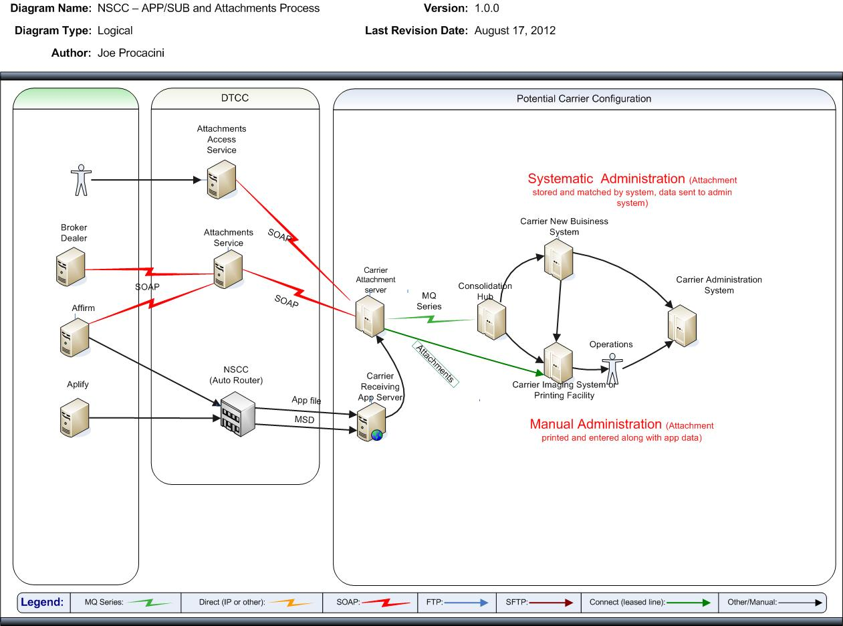

Carrier/Distributor Requirement Decisions for e-Sign:

Client Opt Out process: Client can opt out at any time before their electronic signature is applied to the documents via the E-Sign vendor. If the client opts out during the e-sign process, the distributor will have to get wet signatures and the forms will be sent to the carriers via attachments using the hybrid signature process. The assumption (per Merrill Lynch) is that for the Attachments Pilot – since the consent process applies ONLY to the new business transaction - the client’s right to opt out of signing electronically ENDS once their electronic signature is applied, the documents are locked down and sent back to the distributor. Therefore, if the client opts out of doing business electronically – the carrier will never receive that transaction. We would receive the hybrid signed paperwork and follow our defined business process.

Other internal flow considerations:

- ID the individual documents for e-sign
  - Identify e-sign attachments vs other attachments
- Handle multiple forms instances for e-sign attachments
- May look to create a process which identifies the types of documents (id’s) required for each product so that can systematically check for completeness of forms and auto release orders
- May look to systematically link apps which are e-signed with the e-sign attachments
- Need to look to audit and legal requirements around the e-sign process which may differ from the hybrid or standalone types

Forms and PPfA updates:

- Update the Forms Generation Rules (in FormsXML) so that the forms appear properly during the e-sign process. Denote order, product, state availability and any other form generation rule needed to control the appearance of the form. Utilize Ebix’s signature Named Items as specified in their Forms Implementation Guide.
- Dual e-Consent (IRI Standards – must be presented first)
- Privacy Notice (IRI Standards – must follow Consent form)
- Applications (IRI Standards – must follow Privacy form)
- Replacements
- Any other signature required forms*

* For new money only (not subsequent premium), the carriers need to include only the forms Merrill Lynch has requested in the Lead Kit and Wizard for each of the 4 Merrill Lynch workflows. Merrill Lynch provides a template for the carrier to complete the generation requirements.

- Update the forms to include signature tagging requirements. Ebix is required to send each signing party and related signature tags to SIGNiX. In order to do so, the carrier must tag all signature fields in each of the required forms that are presented during the signing ceremony.

Ebix supports role-based signature requirements. They are customizable by distributor. A conversation will need to occur with the distributor to understand which roles to collect signatures for on the following ownership types:
- Trust
- Custodial
- Single
- Joint

If Owner and Annuitant are different natural owners, no additional signatures should be collected. For Corporate Ownership (i.e. Pension, Defined Contribution, etc), the forms will be submitted via Hybrid in order to allow for Trustee(s) signature and allow for up front submission of the Corporate Resolution. For Power of Attorney, the order will be submitted via Hybrid in order to allow for the up front submission of the legal POA documents.

- PPfA updates – the Carrier must create a new FeatureTransactionProduct to denote they participate in e-sign. And, they designate the AllowedFeatureTransaction to include e-sign on the distributor’s DistributionAgreement.
- PPfA uploading updates – for the Merrill Lynch implementation, Ebix added functionality that notifies the FA when a product is going to change so that the signatures are invalid as of a specific date. The PPfA upload screen must include the dates when you upload your PPfA.
  - Ebix only reads the new fields if Merrill is included as a DistributionAgreement within the PPfA.
  - New dates:
  - WarningStartDate
WarningEndDate

