

IPS Attachment Service Implementation Specification
Version 0.30- Last Update November 22, 2011

Based on the ACORD Life and Annuity Standards v 2.20

1 Introduction 4
1.1 Overview and Objectives 4
1.2 Attachment Overview 5
1.3 Attachment Process Types 6
Standalone Attachment Message Construct 6
Data File and Related Attachment Message Construct 7
1.4 Design Considerations 7
Scalability 7
Adoptability 7
Referential Data Support 7
Delivery Confirmation 8
1.5 Supported Messages 8
1.6 Attachment Assumptions 10
1.7 Basic message level choreography 11
1.8 Requirements and Restrictions 12
1.9 Message Types 12
1.10 Attachment Message 13
1.11 Reject/Accept Response 13
1.12 Recipient Reject/Accept Confirmation Request 14
1.13 Security 14
1.13.1 Transport via DTCC SMART Network 14
1.13.2 Message level security – not in scope for phase 2 15
1.13.3 Data Hash Algorithm 15
1.14 Message Control Table 15
1.15 Hours of Operation 18
1.16 Test Strategy 18
1.16.1 Test Categories 19
1. Connectivity and Message Choreography Scenarios 19
2. New Business Use Case Scenarios 19
3. Custom Scenarios 19
1.16.2 Regression Testing 19
1.16.3 Test Scenario Tracking 19
1.16.4 Script Number 19
1.16.5 Partner Testing 19
1.16.6 Regression Testing 20
1.16.7 Scenario Data 20
2 Message Details 20
2.1 ACORD Insurance Standards 20
2.2 Attachment Message Principles 21
2.3 Use of Type Codes 21
2.4 ACORD XML Message Structure Overview 22
2.4.1 Basic Message Construct 22
2.5 Attachment Structure Details 23
2.5.1 TXLifeRequest/TXLifeResponse Aggregate 24
TXLife Request is used by Sender. TXLife Response is used by Recipient to provide result. 24
2.5.2 Holding Aggregate – Optional on TXLifeRequest, Not Used on TXLifeResponse 28
2.5.3 Party Aggregate – Organization – Required for TXLifeRequest, Not Used on TXLifeResponse 29
2.5.4 Party Aggregate – Person – Optional for TXLife Request, Not Used on TXLife Response 29
2.5.5 FormInstance Aggregate – Required on TXLifeRequest, Not Used on TXLifeResponse 30
2.5.6 Attachment Aggregate – Required on TXLife Request, Not Used on TXLife Response 33
2.5.7 Relation Aggregate – Required on TXLife Request, Not Used on TXLife Response 37
2.5.8 Attachment Source Table – not in scope for phase 1 41
2.5.9 Standard DTCC Attachment Message Structure 43
3 DTCC/ACORD Automated Testing certification facility 44

Introduction
The purpose of this specification is to explain how to utilize the DTCC network to send or receive a message with an attachment(s). This specification addresses the format of the message for attachments. The manner to capture, convert and index documents into the appropriate digital attachment format is outside the scope of this initiative as there are “ready now” services and tools provided by the vendor community that accomplish this step. An ‘attachment’ is any large ‘blob’ of data which is not-structured such as the binary representation of a form, imaged data such as a scanned document, or is data that is intended to ‘pass through’ the DTCC network without edit from Sender to Receiver (e.g. a private stream of data; either private delimited data or XML document). This attachment data may to be in support of one of the existing DTCC IPS Service messages (XML or Flat File) or may be independent of the suite of messages DTCC currently supports.

There may be places in this document that mention phase 2. The initial pilot phase of Attachments will concentrate on New Business only. However, this document will support all business functions that require attachment messages. If you see phase 2 next to any item, it just means it will not be implemented in pilot, but will be supported for the overall attachments process.

Overview and Objectives
Recent regulatory developments have highlighted a need for the annuity industry to have the capability of an electronic exchange of imaged documents, signatures and forms during the pre-sale, new business and post-issue process. Industry standards developed for NAVA STP state that signature capture, either through e-signature or on imaged copies of forms are required at point of sale. NAVA Standards states that PDF/A (ISO-19005-1) is the required PDF format. This signature and the associated paper work must be transmitted to the insurance carrier for the annuity to be processed in-good-order.

Firms are not required to implement an e-signature process to utilize attachments.

To accomplish this task, a stand-alone process is proposed to the industry for handling these items as attachments to the core messaging. This process would leverage the DTCC infrastructure, allow for the transmission of an attachment message and provide for a linkage between the core and the attachments messages, when applicable. The development of an attachment handling process is one of the key components of the National Association for Variable Annuities STP initiative and of great interest to the Federal and State Regulators. This project will be built using a XML based on the ACORD Life and Annuity Standard.

This new service will eliminate the need for a paper exchange of information and enable STP when signatures are required at point of sale and/or original documentation is required for otherwise automated processes. Additionally, firms should realize savings from reduced mailing costs and increase levels of service to distributors, carriers and customer through the expedited document processing. Automation of this process will create an audit trail and eliminate lost paperwork.

The attachment message is not limited to new business transactions. The process may be leveraged to share imaged copies or electronic forms for any transaction when both parties are members of DTCC Insurance Services. For example, signature releases for background checks on Licenses and Appointments, for various forms of customer authorizations, or to transmit contract documents electronically from insurance carrier to distributor.

Goal of the Initiative
Establish a facility to establish an electronic exchange of digital (imaged) documents, signatures, forms and other forms of unstructured data during the pre-sale, new business and post issue processing of annuity and life insurance information.

Today’s environment for new business
Several different methods are used to satisfy the regulatory requirement to gain signatures for new business transactions. These differ by insurance carrier and by state.

Regardless of the individual requirements of insurance carriers and distributors, having a means of sending unstructured binary data is a valuable addition to the DTCC IPS Services.

Future concept for new business

Information is entered at point of sale.
- Data is transmitted to producer back office.
- Attachments which can be either e-signature, imaged copy of paper work or forms are associated with a data feed that may or may not have been transmitted through the DTCC. For example; DTCC APP/SUB or proprietary Application feed.
- ACORD XML message is sent to DTCC including key data and attachment.
- DTCC validates key data and sends information to recipient.
- Both Sender and receiver must be DTCC participants.

Attachment Overview
DTCC’s Insurance Processing Services (IPS) supports a wide array of insurance services. The Attachments guide is meant to be an additional capability for a number of the DTCC IPS messages. Initially, we are focused on the New Business (APP). Replacement processing will be handled as a separate project. Details can be found the Replacement processing user guide. Replacement processing is included in this guide, to highlight that the basic message choreography and processing should work the same whether the attached document is part of the data message, or transmitted as a separate message.

There are unlimited assortments of items that may be handled as an attachment, and this implementation is intended to support any potential use. For example, the following items are examples of possible attachments;
- Forms
- Images

There are 3 types of attachment processes. . The first type of message will support the movement of documents related to IPS fixed format messages, such as APP and LNA. In this case, the attachment message would be sent including key data for the receiver to be able to associate the attached document to the original IPS data transaction. . The second type of attachment message is a business message that does not have a related IPS fixed format message. The same message structure as example 1 would be used. Many of these messages will be converted to the third type of attachment message as DTCC extends our post trade functionality and continues to deploy the associated business messages. The third examples of attachment messages are unique business messages with imbedded attachments, for example Replacements. The structure of these messages is based on the underlying business message and will be defined in separate documentation.

Attachment Process Types
In the work group implementation guide, it has been identified that the attachment process can be used in three different ways:
- Attachment message related to a transactional data file or message (i.e. Attachments message and DTCC IPS APP)
- Standalone attachment message – it will not be associated with a transactional data file or message (i.e. Attachment message by itself)
- A new message can be created to embed attachment objects within the original transaction (i.e. Replacement messages)

The last usage is not in the scope of this work group, and is up to the specific IPS message work group to develop and implement. Therefore the in-scope reject/accept design will focus on 1 and 2.

In the New Business context, there are 5 permutations of using Attachments as a mechanism to transmit Application related documents from Distributor to Carrier.

- A combination of DTCC APP and Attachment Message (Process Type 1)
- A combination of Proprietary Data Files and Attachment Message (Process Type 1)
- The ACORD 103 (NBfA) message and Attachment Message (Process Type 1)
- The ACORD 103 (NBfA) message with embedded attachment objects (Process Type 3)
- Attachment Message by itself (Process Type 2)

For purposes of designing the Attachments Accept/Reject Process, there should be very few differences between these different process types and when there are differences they will be noted.

The standalone attachment message represents an attachment process in its simplest form. Therefore, we will begin by examining the standalone message construct.

Standalone Attachment Message Construct
Logically, the receiver of an attachment message can choose to reject the entire message or a single attachment object in the message. Reject reasons could range from illegible content, invalid MIME type, unsupported document type, and more.

For pilot, the reject process will apply only to the entire message and not to each attachment object

The logical construct for a standalone attachment message is shown in the diagram below.

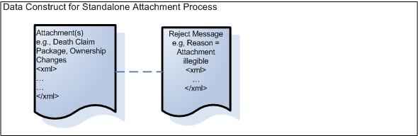

Data File and Related Attachment Message Construct
An attachment message associated with a transactional data file or message such as DTCC IPS APP, or DTCC IPS LNA has similar qualities as a standalone attachment message. A request will contain single attachment message, which in turn contains one or more attachments objects.

As was the case of the standalone message, pilot will reject at the message level and not at the individual object level.

Design Considerations
Message transmission between participants of the DTCC Attachment system must be able to address the current and future needs of the insurance industry. In order to do so, several design aspects to be considered are:
- Scalability
- Adoptability
- Referential data support
- Delivery confirmation
- Security

Scalability
This aspect is addressed by making sure that connection between parties is asynchronous and stays open as briefly as possible. The key is to minimize the impact of each participating system on the Attachment messaging channel. For instance, Sender submits a message to DTCC and immediately closes the connection, without having to wait for DTCC to deliver it to the recipient. Instead, DTCC will send a confirmation to the Sender whether the message has been received.

Similarly, the recipient of a message in any direction must not keep the connection occupied and opened longer than the mutually agreed upon timeout period. For example, the recipient must not perform time-consuming data validation on the attachment message.

Adoptability
The attachment message specification must ensure that current and future business processes (e.g. replacement, LNA, custodial) can utilize the attachment process without having to change their respective message format.

Referential Data Support
The attachment message must allow the receiving system to identify the related IPS messaged, if any, and meta-data about the attachment such as the business process, the document type, and the associated policy #, etc. These meta-data is essential for the receiving system to route the attachments correctly.

Delivery Confirmation
From a Sender’s perspective, once an attachment message is sent, a DTCC confirmation is expected within a time period to indicate whether the attachment has successfully reached and been accepted by the recipient.

An attachment message can be rejected by DTCC or by the recipient.

For Pilot, the receiver (Carriers) may perform basic validation steps on the message and may automatically reject in the SOAP response on technologically detectable reasons such as incompatible image type. They will not reject for business reasons that are not machine detectable such as illegible image, or missing forms.

For future phases, a received attachment message can be rejected for various business reasons, such as illegible image, inactive policy, etc. However, the resubmission of a rejected message is considered brand new attachment message, and should have a different message identifier (TransGUID).

Supported Messages

Example 1 – Attachment for messages that are sent through DTCC. These messages would be IPS fixed format files such as APP and LNA.

Some of these documents may be used for in force transactions. In that case, the form may also be listed in example 2.

Examples of documents include:
- Application Package forms (Point of Sale forms)
- Replacement paperwork from Broker to Carrier
  - State Replacement forms
  - Transfer forms
  - NY Reg 60 forms - phase 2
  - Rollover forms
  - Internal Replacement Questionnaire
  - Power of Attorney/Affidavit/Questionnaire
- Identity Documents
  - Birth Certificate
  - Driver’s License
- Tax forms
- Client Correspondence
- Cross Border form
- Client e-Consent information
- Application related - Carrier specific form
- Bank Draft
- Contract
- Confirmations
- Trust Legal documents
- Charitable Remainder Trust
- Corporate Trust documents
- Agent Appointment and Licenses
  - New Appointment
  - Renewal
  - Termination
  - Change in agent information

Example 2 – Documents for attachment transactions that have no related DTCC business transaction.

This would follow the same format as example 1 but would not associate with a current IPS fixed format transactions.
- Statements
- Death claim package
- Prospectus
- Proof of Delivery for Free Look

Several forms/documents will be sent as an example 2 until such time that DTCC deploys the associated in- force transactions to support the underlying business transaction.
- Trust Legal documents
- Charitable Remainder Trust
- Corporate Trust documents
- Post Issue – Carrier specific forms
- Fund Transfers/Allocations
- Asset Allocations
- DCA (Dollar Cost Average), Special and Regular, Interest Sweep
- Systematic Withdrawal
- RMDs
- Annuitization
- Full Liquidation
- Partial Liquidation
- Ownership changes
- Beneficiary changes
- Annuitant changes
- Custodial changes
- Rider/Service feature changes

Example 3 – Transactions that are designed to include attachments. Documentation would be contained within separate user guides.

Carrier to carrier replacement documents will be example 3.
- State Replacement forms
- Transfer forms
- NY Reg 60 forms
- Rollover forms
- Power of Attorney/Affidavit/Questionnaire
- Client correspondence related to Replacements

As stated in example 2, DTCC is planning on expanding the in-force transaction set. Transactions that will initially be included in example 2 will be considered example 3 transactions after DTCC deploys new in force business transactions.
- Illustrations
- Fund Transfers/Allocations
- Asset Allocations
- DCA (Dollar Cost Average), Special and Regular, Interest Sweep
- Systematic Withdrawal
- RMDs
- Annuitization
- Full Liquidation
- Partial Liquidation
- Ownership changes
- Beneficiary changes
- Annuitant changes
- Custodial changes
- Rider/Service feature changes

Attachment Assumptions
Key points and assumptions:

- This structure will be capable of but not limited to supporting any DTCC IPS Service message
- Existing IPS fixed format messages will be enhanced to include an indicator to alert the receiver that an attachment message will be transmitted.
- This message will be based on XML, following the ACORD Life and Annuity Standard, using the version noted on the title page of this document.

Basic message level choreography
The basic scenario from the perspective of the Sender is as follows:
- The Sender transmits Attachment Message to DTCC (#1 in diagram)
- The Sender receives a Response from DTCC indicating if the Attachment Message has either passed or failed DTCC validation. (#1a in diagram)
- The Sender receives a Recipient Reject/Accept from DTCC indicating if the Attachment Message was or was not successfully delivered to and accepted by the Receiver and returns a response to DTCC (#3 and #3a in diagram)

The basic scenario from the perspective of the recipient is as follows:
- The recipient receives Attachment Message from DTCC, performs auto-detectable validation edits on the message, and returns a Recipient Reject/Accept response to DTCC (#2 and #2a in diagram)
- The recipient receives a Request message from DTCC if the Reject/Accept SOAP Response did not pass DTCC validation and returns a response to DTCC (#4 and #4a in diagram)

Here is the basic choreography of sending an Attachment Message

Requirements and Restrictions
To ensure proper implementation, all parties involved in the messaging logic must adhere to the specified messaging guidelines.

- DTCC Attachment participants must have the capability to both send and receive messages to and from DTCC via web services.

- For Pilot, an attachment transmittal is strictly concerned about the sending of an attachment from a Sender to the receiver, over the DTCC channel. It precludes the scenario where the receiver initiates an attachment request, although it is probable for future enhancement.

- An automatic re-transmittal request due to a reject, is not allowed in this implementation because the re-transmittal request is highly dependent on the attachment business scenario, reject reason, and message type.

- For an attachment that pertains to another DTCC message, the order of arrival of either the associated DTCC message or the attachment message(s) should not be used to determine the validity of attachment messages, for good reasons. For example, if the related IPS message has not arrived by n days, it is up to the business process (e.g., application, replacement, etc.) to reject the request. Such rule should not be reinforced by the attachment logic. N would be determined by individual firm.

- Firms will be required to use MTOM to send the attachments. Inline attachments will NOT be permitted though DTCC.

MTOM is the W3C Message Transmission Optimization Mechanism, a method of efficiently sending binary data to and from web services. It uses XOP (XML-binary Optimized Packaging) to transmit binary data and is intended to replace both MIME and DIME (DIME is a lightweight, binary message format that can be used to encapsulate one or more application-defined payloads of arbitrary type and size into a single message construct) attachments. At the very beginning of web services people thought of sending text data with SOAP messages. But after some time people thought of sending binary files as a SOAP request or sending a sound clip as a web service request. So as a solution to these problems MTOM came into the act.

http://www.w3.org/TR/soap12-mtom/

Message Types
As described in the sequence diagram, three types of message are necessary to ensure the delivery of attachment messages over TCP/IP connections:

- Attachment Request Message
- Reject/Accept Response
  - DTCC
  - Recipient
- Recipient Reject/Accept Confirmation Request

Attachment Message
An Attachment message (Steps 1 and 2) contains one or more Forms Instance objects each representing one attachment. It flows from the Sender to the intended recipient. The ACORD TXLifeRequest message format for TransType code 510 has been adopted for this purpose.

Reject/Accept Response
When a message is submitted to another party, a SOAP response is returned to reflect the submission result (e.g., Sent/Received/Failed/Rejected). This is equivalent to the return code of a web service call between the participants. The standard TXLifeResponse construct will meet this need.

A Reject/Accept message contains receipt and acceptance results for the Attachment message and is sent by DTCC or the attachment recipient

DTCC (Step 1a)

Scenario in the Sequence Diagram | ResultCode | ResultInfo  Code | ResultInfoCode Description
Step 1a – Attachment message was accepted (successful) | 1 | Not Used
Step 1a Attachment was rejected (failure) | 5 | 200 | DTCC System Validation Error (only used by DTCC)
Step 1a – Attachment message was rejected (failure) | 5 | 103 | DTCC does not support the Mime Type
Step 1a – Attachment message was rejected (failure) | 5 | 104 | DTCC does not support the AttachmentType code
Step 1a – Attachment message was rejected (failure) | 5 | 2003 | Document Control Number is invalid (i.e. missing for 103 TransType)  Required element missing  Include resultinfodescription with name of the element.

Recipient (Step 2a)

Scenario in the Sequence Diagram | ResultCode | ResultInfo  Code | ResultInfoCode Description
Step 2a – Attachment message was accepted (successful) | 1 | Not Used
Step 2a – Attachment message was rejected (failure) | 5 | 100 | General Error – used for any reject that does not have a specific error code assigned.
Step 2a – Attachment message was rejected (failure) | 5 | 203 | The request contains a transaction type that the receiver does not process
Step 2a – Attachment message was rejected (failure) | 5 | 114 | The receiver does not accept attachments from this Sender.
Step 2a – Attachment message was rejected (failure) | 5 | 107 | The receiver does not support the Mime Type. For instance the receiver may accept PDF but not TIF, therefore they can reject on TIF
Step 2a – Attachment message was rejected (failure) | 5 | 106 | The receiver does not support the AttachmentType code
Step 2a – Attachment message was rejected (failure) | 5 | 113 | Document is not expected based on the OriginatingTransType
Step 2a – Attachment message was rejected (failure) | 5 | 2044 | Duplicate of a previous transaction. . Based on DocumentControlNumber or TransRefGUID

Other Codes:

Scenario in the Sequence Diagram | ResultCode | ResultInfo  Code | ResultInfoCode Description
Step 2a – Attachment message was rejected (failure) | 5 | 105 | Unable to decode the transaction – Out of scope
Step 2a – Attachment message was rejected (failure) | 5 | ? | Follow-up attachment message does not have the same originating TransType – Out of scope for pilot (Issue list)
Step 2a – Attachment message was rejected (failure) | 5 | 2002 | Duplicate Object Found. For instance two Application documents on the same attachment message – Out of scope
Step 2a – Attachment message was rejected (failure) | 5 | 115 | Hash Code Mismatch  Carrier validates Hash code and it does validate properly.
Step 2a – Attachment message was rejected (failure) | 5 | 300 | System Unavailable

Recipient Reject/Accept Confirmation Request
A Confirmation Request is a new transmittal message (SOAP Request) with a TXLifeResponse Payload. This message will used to update the Sender of the Reject/Accept status of the original Attachment message. This corresponds to Step 3 on the diagram. If the original Reject/Accept Response (Step 2a) failed DTCC validation this message will also be sent to the recipient. This is Step 4 on the diagram

Security

Transport via DTCC SMART Network
All companies using this functionality will be participants of DTCC. DTCC provides each participant with communications infrastructure through the SMART network. The SMART network will provide for router level encryption. (For more information on the SMART network, see the “Complete Guide to SMART” document).

http://www.dtcc.com/products/documentation/technology/SMART%20user%20guide.pdf

Message level security – not in scope for phase 2

Currently, MLS is only available for the Fund Transfers product. See Message Level Security Technical guide for Fund Transfers for detailed information.

Data Hash Algorithm

As part of Attachment message, the send is required to include a hash algorithm using Secure Hash Algorithm 1 (SHA-1). The Hash elements are located in the Attachment aggregate (see 2.5.6). The Hash will verify the attachment content against data corruption independent of the file type (PDF, TIF).

Message Control Table
Each message will have a standard format with a sub transaction code to indicate the business event the attached information is intended to support. To enable companies to implement independent business functionality and not be required to support or reject each type of business event, DTCC will create a control table. The table will enable each participant to authorize the type of business events that they wish to receive. DTCC will validate and reject if necessary any business event not indicated on the table.
Once authorized to receive a business event, all trading relationships may submit that transaction to the receiving participant.

DTCC will create a control table similar to one being used in the L&A Access web-based functionality. There will be a screen for both Test and Production

Defined Data Points for Control Table Requirements:

- Participant NSCC ID = (can we do this at a family level)

  - Business Process/Message type = “510” - Value doesn’t change for this purpose.

    - Originating Transaction type = (ex “103” = New Business)
      - Originating SubTransactoin Type – not available at this time
      - Mime Type - Select one or more from the current list of MIME types supported for this availability.

      - Message Level Security – Phase 2 = Provide a list to define what is supported

      - Trading Partner Info (NSCC Id) – currently available
        - Dates:- not available at this time
        - Start date – May be future-dated
        - End date - Used to terminate the availability

Screen shots

Portal/Application Login

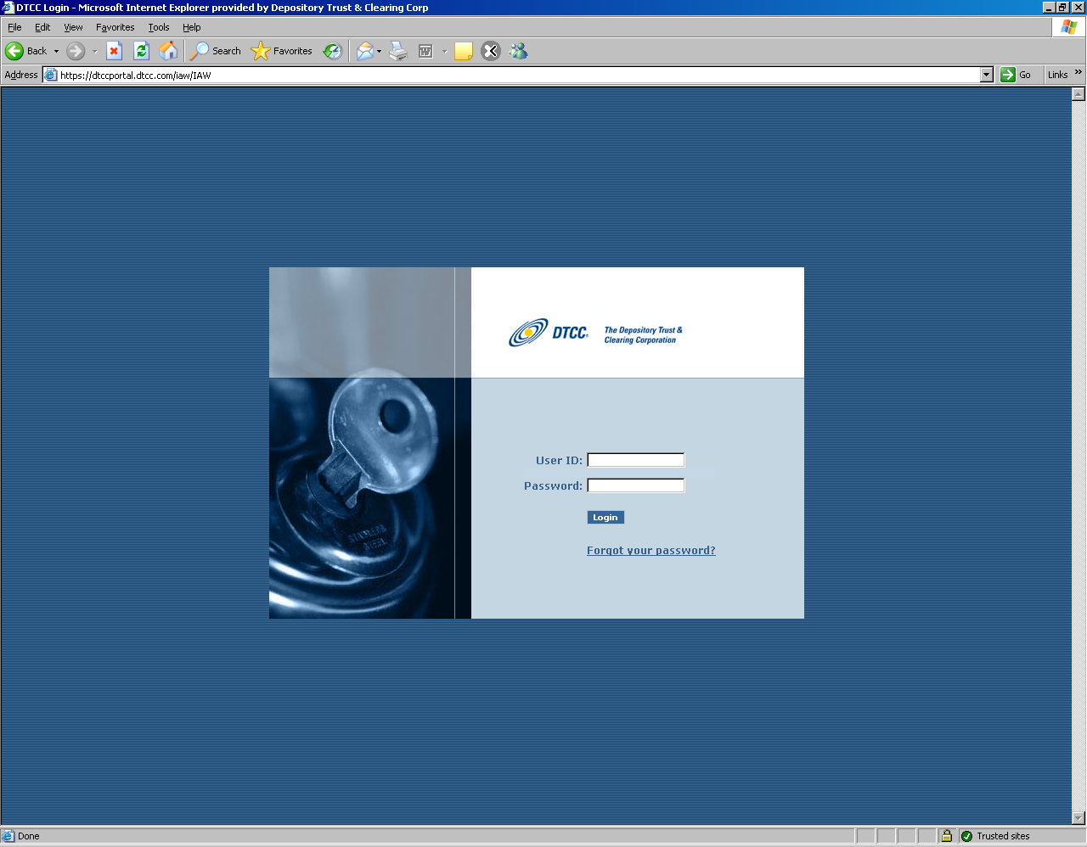
Select Tag screen – This is optional screen, if user has multiple participant numbers this will appear

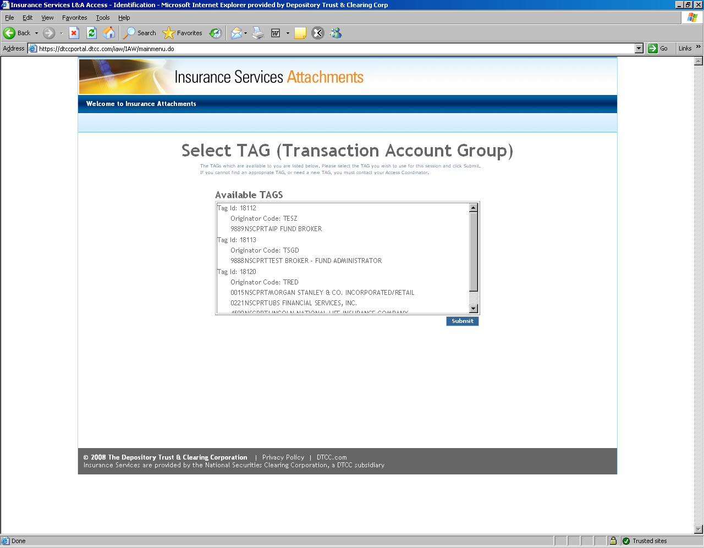

Select Participant – Drop down if user has multiple ids or non editable if has only one

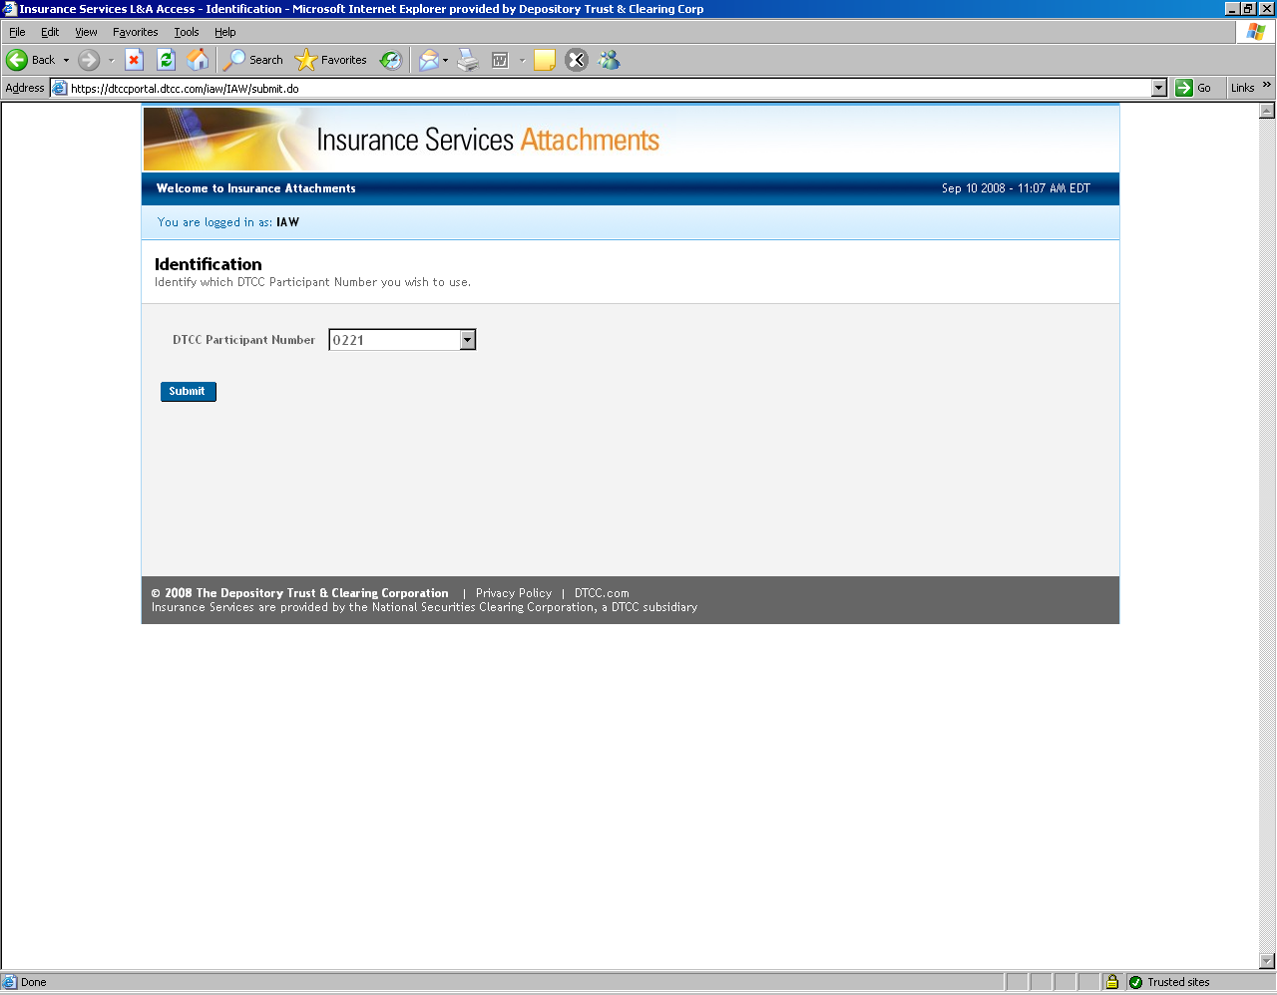

Hours of Operation
DTCC Hours

Monday to Friday – 6am to 10 pm et
Saturday – 6am to 3pm

System will run on Bank Holidays

Test Strategy

The overall testing plan is broken into 3 categories of tests. In order, they are:
- Connectivity and Message Choreography Scenarios
- New Business Use Case Scenarios
- Custom Scenarios

It is expected that the majority of each category is completed successfully prior to moving on to the next category since each category builds on the prior category. Each category is detailed below.

Test Categories

Connectivity and Message Choreography Scenarios
These scenarios test for basic connectivity between partner firms and the DTCC. In addition they ensure correct message choreography and basic exception handling as outlined in the implementation guide are adhered to. These tests can be accomplished without a fully implemented business process.

New Business Use Case Scenarios
These scenarios are a direct reflection of the Use Case scenarios created by the group for the New Business usage as defined in the STP Pilot. It is expected that you have passed the basic connectivity tests* and have the necessary business processes in place to support the scenario.

* It is possible to have some basic connectivity scenarios in progress and still be able to move forward with New Business cases. Example: You fail the handling of duplicate TransRefGuids and are applying fixes. This should not preclude you from testing certain New Business Use Cases. Common sense will guide us.

Custom Scenarios
These are scenarios that are outside the scope of testing for piloting New Business. This section is provided for your convenience. You should not expect any support for these scenarios if they do not pertain to New Business.

Regression Testing
It is expected that issues will arise during testing that will require the retest of individual scenarios or even an entire category of scenarios. DTCC changes to business rules and schema will be communicated prior to the change being implemented. The group should evaluate the change impact on the test scenarios and determine if regression testing is warranted and to what degree. The test scenario spreadsheet provides for tracking iterative testing of scenarios.

Test Scenario Tracking
The DTCC Attachments Testing Scenarios.xls template was created to assist you in organizing your test results. Here are some guidelines for utilizing the spreadsheet effectively.

Script Number
Each test scenario should have a unique script number. We should also strive to keep these values uniform across the group so when discussing scenarios we have the same reference. If you must create a new test based on a common scenario perhaps because of different scenario data use decimal notation:

CTS1
CTS1.1 etc.

Partner Testing
For each Distributor and Carrier combination a separate tab should be created and the name (and\or member code) should be added to the tab. Generally the initiator of a test is the Sender. It is the responsibility of the initiator to record and pass the results onto their partners who can record the results within their own spreadsheet.

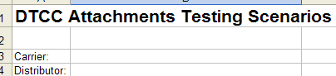

Regression Testing
For retests of scenarios, an iteration column is available. You can create a new row under the test scenario and enter in the cycle number for the retest as well as record the date and results.

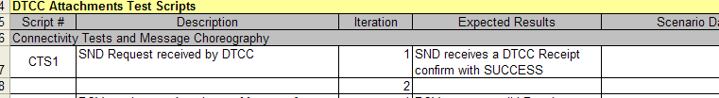

Scenario Data
Some test scenario may require the coordination across systems or require specific data values such as APP IDs or contracts. The Scenario Data column allows you to capture these values.

Message Details

ACORD Insurance Standards
The message defined in this implementation guide is based on the ACORD Life and Annuity Standards. ACORD provides an open insurance industry XML vocabulary which defines a common, consistent view of insurance information. All messages herein are based on the ACORD Life Standards Data Model. This means every message regardless of Sender and/or receiver (or systems) and regardless of process all share a consistent means of describing like data – a Policy is always a Policy and is always formatted and defined the same. This consistency reduces translation effort (and errors) and insures that all participants in the insurance value chain can share a common understanding as well as view of insurance data.
For more information contact ACORD at Life@acord.org. The public standards are available on their website at www.acord.org.

Attachment Message Principles
The following basic premises apply all the Attachment messages.
- Message is based on ACORD’s Version 2.20.00.
- Real time message response is expected.
- DTCC will provide XML Schemas (XSD’s) for this message. These schemas serve two purposes, first allowing creators of these messages to validate their work against the schemas and second as the production reference from which DTCC will validate these XML messages passing through the DTCC IPS network.
- Several of the identifiers on objects, including the principle one identifying the message itself TXLife/TransRefGUID, all call for a Globally Unique Identifier (GUID) or UUID. This is a large string which is programmatically generated and virtually guaranteed to always be unique.
- Every Request message must have its own GUID. Every Response message, if applicable, MUST return the TrasnRefGUID of the original Request message.
- One or more attachment documents must be included within an attachment message.
- Each attachment message must be for a single recipient.
- Each attachment message must relate to single discreet business event.
- DTCC supports two MIME types (PDF or TIFF). It is up to the trading partners to determine the acceptable MIME type to be used. Note: There are various types of PDF formats that may need to be supported such as File-PDF, Image-PDF, Application-PDF. This needs to be confirmed with trading partners.
- Multiple documents may be imaged and transmitted as a single attachment object (glob). It is up to trading partner on how they image and transmit or receive and unbundled globed documents.
- For non-esign submission, there are cases in which a receiving firm may receive multiple forminstance in a single message.
  - Ex – Agent faxes documents in two steps which causes to form instance objects, system related fax errors, corrections to original documents.

Use of Type Codes
Wherever possible, the ACORD Data Model uses lookup codes or tables, what they refer to as typecodes as the data type for elements of the model. These are much easier to process than strings. They are easy to identify as attributes on each XML Tag, like this: <TransType tc=”103”>New Business</TransType>. The ‘tc’ attribute is always on every typecoded element and that is the value you should reference and use when processing the message. The text between the tags, in the case of type code values, is optional and should NOT be processed.
Through this specification we will clarify which typecode values are relevant to the messages here.

ACORD XML Message Structure Overview
The ACORD Life and Annuity Standards are built first on a common data model. All specific insurance business processes, AKA messages, are then defined using the life data model, with only those elements necessary are used. All messages however will always define a given element in the same way, thus promoting reuse, consistency and a common vocabulary for describing insurance concepts. When looking at only a specific message the design of the message may seem un-optimal, and indeed it most likely is. This is due to the greater objective of always having insurance concepts modeled in the same consistent method regardless of process or message.

Basic Message Construct
Every message begins with a message or transaction ‘header’. It defines the transaction type and transaction level information like date & time, etc. Its’ basic form is…
TXLife
TXLifeRequest (created by Sender)
OLifE (specific message business data)

And then the response comes back as…
TXLife
TXLifeResponse
TransResult ← Location of success or failure and details
ResultInfo

Each message then has a specific set of expected business data to accompany or be returned in a request or response message. The basic form for the messages here (a subset of the overall ACORD Life Data Model) is…

For an Attachment we simply append the attached data as follows, in line, with where the attachment is relevant or applies. This mimics the pattern for all ACORD msgs (with or without an attachment, for reuse and consistency).
TXLife
TXLifeRequest
… Transaction Details
OLifE
Holding (or <Party> or <FormInstance>)
Attachment
… Attachment details
Party : Sending Party
Party : Receiving Party
Relation : Associate Sender with Primary Message Object (e.g Holding, Party of FormInstance)
Relation : Associate Receiver with Primary Message Object (e.g Holding, Party of FormInstance)

Attachment Structure Details
Table Legend:
DTCC Element: Basic name of field
ACORD Element: actual name of data element in the ACORD schema.
DTCC Validates: “Y” = Yes DTCC edits/validates, “N” or blank they do not
Use: “R” = Required, must be provided, “C”=Conditional with the condition when it’s required defined. If a notation (ex R) is indicated. This is a reference to the ACORD Testing Certification Facility (SEE SECTION 3). This references the type of error that would occur in the testing facility is the rule is not followed.
In the ACORD Element section are two specific description notations. The first sentence is the parent object and property or attribute where the information is stored.
Type: “A” = Aggregate or container object, “B=Boolean, “S” = String, “D” = Date, “T” = Time, “C” = Currency Amount.

The DTCC will validate the following:
- Specified field formats are followed
- Required fields are present
- Other specific DTCC validations defined in the definition section

TXLifeRequest/TXLifeResponse Aggregate

TXLife Request is used by Sender. TXLife Response is used by Recipient to provide result.
Definition | ACORD Element | DTCC Validate | Use | Type
Pointer to the principal object where the Attachment data object <Attachment>can be found.  Must point to the FormInstance object ID.  For e-signed documents, the @PrimaryObjectID will point to the form instance for the document manifest, if one is available. This will tell the programmer where to begin parsing the documents. For hybrid documents where there may not be a separate document manifest, the @PrimaryObjectID will point to the first form instance that contains the scanned documents. | @PrimaryObjectID | Y | R | IDREF
Transaction Reference Guid  Unique Identifier for this message.  Used later in the response (if sent) to link the response with the original request.  GUID in response must match GUID from request. | <TransRefGUID> | Y | R | GUID
Business Process / Message Type  510 = Forms Instance (Attachment) | <TransType tc=”#”> 510 | Y | R | Type Code
The TransSubType further defines the TransType of 510 into an attachment message. This element is required if message is sent in accordance with NAVA STP.  NAVA e-docs specifies TransSubType tc="1022500300">Attachment </TransSubType>.  This is required for 2.20 schema validation.  This field should be optional. If the Carriers are sending the attachment in accordance with the edoc specific NAVA implementation, then the code above should be sent. Otherwise, this element may be excluded. | <TransSubType tc="1022500300">Attachment </TransSubType> - | Y | O | Type Code
For TXLife Request - Date Message was created.  For TXLife Response – Date Message was responded to  The standard date will be yyyy-mm-dd date. Example: 2008-04-24 | <TransExeDate> | Y | R | Date
Time Message was created. Attachments will utilize the GMT offset with the NY time being the base; so, the offset will be either -4 or -5. The time format will be 20:49:01-04:00 . | <TransExeTime> | Y | R | Time
Test Indicator  0 = False (Production)  1 = True (Test) | <TestIndicator tc=”#”> | Y | R | Boolean
Indicator of what the object type is that the PrimaryObjectID is pointing to, so receiving system easily knows what to expect.  Only expected Value:  101- Form Instance | <PrimaryObjectType tc=”101”>Object Type | Y | R for TXLife Request  Not Used for TXLifeRespons | Type Code
Correlation Identifier– to be used to relate multiple attachment messages. This will only be used in Phase II implementation. | <CorrelationGUID/> |  | O for TXLife Request  Should be passed back on TXLifeResponse if received. | GUID
Specifies the state of the CorrelationGUID.  1 - Initial  2- Ongoing  3 - Final | <CorrelationGUIDState tc=""/> |  | C  Req if CorrGuid present | Type Code
Container object for the business message details | <OLifE> | Y | R for TXLife Request  Not used for TXLife Response

TransResult – Required in TXLife Response only. Not used for TXLifeRequest
Definition | ACORD Element | DTCC Validate | Use | Type
 | <TransResult> | Y | R | Object
Result Code  1 = Success  5 = Failure | <ResultCode tc=#”> | Y | R | Type Code
Result Details – Only applicable if an error. | <ResultInfo> | C | C  If 5 (failure), then required  If 1, not used. | Object
Detail code defining error  See code list Section 1.11  DTCC will use code 200 for validation errors. Firms will not be allowed to use this resultinfocode for their own use. | <ResultInfoCode tc=”#”> | Y | R | Type Code
Description of the issue/error. May clarify or expand upon the code meaning potentially with instructions how to remedy or what to do to fix.  This is only expected in cases where the code is not clear. Please refer to the ResultInfoCode list below. | <ResultInfoDesc> | Y | C  Req for ResultInfo Code = 2003 | String
Used by DTCC only  DTCC will use this field on edit rejects to indicate DTCC reject reason.  Example – Invalid TransRefGuid | <ResultInfoSysMessageCode> |  | DTCC Only | String

Holding Aggregate – Optional on TXLifeRequest, Not Used on TXLifeResponse
Holding is conditional based on originating transaction type. Expected for New Business (@CarrierPartyID and CusipNum)

Definition | ACORD Element | DTCC Validate | Use | Type
Unique Identifier for the Holding | @id | Y | R | IDREF
 | <Policy> |  | R | Object
 | @CarrierPartyID |  | R | ID
It was noted by the WG that the PolicyNumber may not be known (as with New Business). If it is blank, the Holding aggregate should still be sent with Cusip and CarrierPartyId. | <PolNumber> |  | O | String
CUSIP Number – product cusip  Starting on September 24, 2009, DTCC will require CUSIP to be included when OriginatingTransType = 103 (New Business)  CUSIP will be validated against the DTCC CUSIP profile. Any cusip not in the profile will be rejected back to the submitter. | <CusipNum> |  | C  Will change to Conditional starting in Sept 09 | String

Party Aggregate – Organization – Required for TXLifeRequest, Not Used on TXLifeResponse
Must have a minimum of two Party>Organization Aggregates for TXLifeRequest. One for Sender and one for recipient. DTCC needs the DTCC member code for each organization to the message.

 | ACORD Element | DTCC Validate | Use | Type
Unique Identifier for the Party | <Party @id> | Y | R | ID
Indicates whether the party being described is a person or an organization  2 = Organization | <PartyTypeCode tc=’2’> | Y | R | Type Code
Legal name of the organization | <FullName> | Y | R | String
Detail about the Organization | <Organization> | Y | R | Object
DTCC Participant number | <DTCCMemberCode> | Y | R | String
Associated Firm Id – used when there is a corresponding firm associated with a DTCC Member organization. DTCC will not validate the value of the OrgCode. | <OrgCode> | Y | O | String

Party Aggregate – Person – Optional for TXLife Request, Not Used on TXLife Response
 | ACORD Element | DTCC Validate | Use | Type
Unique Identifier for the Party | <Party @id> | Y | R | ID
Indicates whether the party being described is a person or an organization  1 = Person | <PartyTypeCode tc=’1’> | Y | R | Type Code
Detail about the Person | <Person> | Y | R | Object
Last Name | <FirstName> | Y | R | String
First Name | <LastName> | Y | R | String

FormInstance Aggregate – Required on TXLifeRequest, Not Used on TXLifeResponse
There will be no more than one attachment object associated with each form instance. – need to document how we will embed the detail from the document manifest.

Definition | ACORD Element | DTCC Validate | Use | Type
Unique Identifier | FormInstance @id | Y | R | ID
ProviderPartyID  - should be the Sender. This is needed to relate the FormInstance to the Sending Party. | ProviderPartyID @id | Y | R | ID
ReceiverPartyID  - should be the Recipient. This is needed to relate the FormsInstance to the Receiving Party  Need MR to add to FormsInstance for 2.20 | ReceiverPartyID @id | Y | R | ID
Form Name | <FormName> | Y | O | String
Provider Form Number – for document manifest | <ProviderFormNumber> | Y | O | String
DocumentControlNumber. Provides a unique identifier for the forms that are attached to the message. There is a one for one correlation between FormInstance and New Business transaction.  DTCC will edit to ensure that each occurrence of FormsInstance within one TXLife Request has the same document control number.  For None (2) (no electronic message will be sent) – this should be blank element should not be sent | <DocumentControlNumber> | Y | C | String
Document Control Type Qualifier identifies the type of data contained within the Document Control Number  1 – Order Entry Control Number – The control number assigned to the electronic order at the time of order entry (used from DTCC APP paperwork record)  2 – None – There is not a corresponding Document Control Number. This will be used when it is a standalone attachment  This field is required when <DocumentControlNumber> is sent | <DocumentControlType>  OLI_DOCCTRLQUAL_ORDERENTRY  OLI_DOCCTRLQUAL_NONE | Y | C | Type Code
Originating Transaction Type.  This field is used to define the business event that the attachment object is related to.  Available types:  103 – New Business / i.e. DTCC APP File  107 – Arrangement Administration  508 – Sub Payment / i.e. DTCC Sub file  1213 – Financial Activity Transmittal / Confirms  1235 – Holding Statement Transmittal / Statements  181 – Address Change Request  183 – Email Address Change Request  182 – Phone Change Request  186 – Party Update  102 – Fund Transfer  185 – Update Financial Activity  410 – Appointment Request  413 – Appointment Termination  129 – License Request | <OriginatingTransType tc=”###”>  Originating Transaction Type | Y | R | Type Code
Originating Transaction SubType  Not to be used in phase 1 (not needed for new business). Code list needs to be further analyzed.  *Note: Element is part of 2.20 MR. No codes added as part of 2.20 | <OriginatingTransSubType tc=”###”>  Originating Transaction Sub Type  TRANS_SUBTYPE_CODES | Y | O | Type Code
Signature Object | <SignatureInfo> | Y | O
Attachment Object | <Attachment> | Y | R

SignatureInfo Aggregate – Optional on TXLife Request, Not Used on TXLife Response
Definition | ACORD Element | DTCC Validate | Use | Type
Unique ID | <SignatureInfo @id> | Y | R | ID
SignaturePartyID - used to point to party this signature is related to. | FormsInstance.SignatureInfo.SignaturePartyID | Y | R | IDREF
Signature Role  Role code describing signer's relationship to the form. | FormInstance.SignatureInfo.SignatureRoleCode  OLI_LU_PARTICROLE – need to determine exact role codes accepted. | Y | R | TypeCode
Signature Date  On SignatureInfo, documents the date on which the signature party performed the signature.  The standard date will be yyyy-mm-dd date. Example: 2008-04-24 | FormInstance.SignatureInfo.SignatureDate | Y | R | Date
Signature Time  On SignatureInfo, documents the time at which the signature party performed the signature.  SignatureTime will utilize the GMT offset with the NY time being the base; so, the offset will be either -4 or -5. The time format will be 20:49:01-04:00 . | FormInstance.SignatureInfo.SignatureTime | Y | R | Time

Attachment Aggregate – Required on TXLife Request, Not Used on TXLife Response
Definition | ACORD Element | DTCC Validate | Use | Type
Unique ID | <Attachment @id>
Attachment Date | <DateCreated> | Y | R | Date
Attachment Data  This is where the Attachment data is placed in scenarios where document is not attached to this attachment aggregate. Used for document manifest.  Note: AttachmentData64 and AttachmentData are mutually exclusive. Sender must choose on of these data types in the aggregate. Cannot send both. | <AttachmentData> | Y | C  Required if Attachment64 is not used | String (ANYDATA)
Attachment Data Base64Binary  Used for attachments that includes the imaged document constructed via the use of MTOM.  Note: AttachmentData64 and AttachmentData are mutually exclusive. Sender must choose on of these data types in the aggregate. Cannot send both. | <AttachmentData64Binary> | Y | C  Required if AttachmentData element is not used | base64binary
Type of Attachment – Defines what the attachment data is.  Starting on September 24, 2009, DTCC will not validate against the ACORD code list. DTCC will allow any value.  Suggested Code List:  1 – Document – specifics undefined  2 – Comment or note text  5 – Form (generic, actual type unknown) – std form  10 – Original Application – preferred over 5  See also specific form types for ACORD forms, e.g.  73 – ACORD 951 Replacement Form  Codes recommended as part of NAVA STP. These can be used in place of codes listed above.  2550010 Account Opening Form  2550020 Electronic Consent Form – Carrier  2550030 Electronic Consent Form – Distributor  2550040 Variable Annuity Contract Prospectus  2550050 Fund Prospectus  2550060 Variable Annuity Profile  2550070 Fixed Annuity Profile  2550080 Indexed Annuity Profile  2550090 Risk Tolerance Questionnaire  2550100 Privacy Notice  2550110 General VA Disclosure (rule 2821)  2550120 Compensation Disclosure  2550130 Conflicts of Interest Disclosure  2550140 Sales Summary Disclosure  2550150 NAIC Buyers Guide – Fixed | <AttachmentType tc=#>  Attachment Type | Y | R | Type Code
Form
2550160 NAIC Buyers Guide – Variable
2550170 NAIC Buyers Guide – EIA
2550180 NAIC Disclosure – Fixed and EIA
2550190 Annuity Application – NAVA Compliant
2550200 Annuity Application – Non NAVA Compliant
2550210 Trust Document Certificate
2550220 Systematic Withdrawal Form
2550230 Telephone or Electronic Transaction Authorization
2550240 Jumbo Case Review Form
2550250 Tax Disclosure Form – W8
2550260 Tax Disclosure Form – W4P
2550270 Power of Attorney Affidavit
2550280 Rider Reset Authorization Form
2550290 Annuitization Authorization Form
2550300 Interest Sweep Form
2550310 Asset Rebalancing Form
2550320 Dollar Cost Averaging (DCA) Form
2550330 NAIC Model Reg Replacement Form
2550340 Non- NAIC Model Replacement Form
2550350 New York Regulation 60 Disclosure Form
2550360 Exchange/Rollover Transfer Form
2550370 Suitability Determination Form
2550380 Customer Confirmation Form
2550390 Welcome Letter
2550400 Annuity Policy Contract
2550410 Proof of Delivery Statement
2550420 Guaranty Association Notices
2550430 Qualified Plan Disclosures
2550440 Service Forms
2550450 Buyers Guide (Non-NAIC)

Mime Type  The type of attachment that follows.  11 – Image/ TIFF  17 – File/PDF | <MimeTypeTC tc=#>  MIME Type | Y | R | Type Code
The method of encoding the Attachment Data  4 – Base64  This is used for encoding of base64Binary | <TransferEncodingTypeTC tc=”#”>  Transfer Encoding Type | Y | R | Type Code
AttachmentBasicType – is this needed. Was in XML sample but not in data dictionary  1 = Text  3 = File (for binary attachments) – This one will be most commonly used for this product. | <AttachmentBasicType tc="3">File</AttachmentBasicType>
Attachment location – include in the message or a URL to the document  5 – XOP Include | <AttachmentLocation tc=”5”> | Y | R | Type Code
Attachment Hash – The hash result or digest used to verify the attachment content against data corruption independent of the file type (PDF, TIF) | <AttachmentHashValue> | Y | R | String
Attachment Hash Type – The type of data hash algorithm used.  Must be filled with SHA1 if <AttachmentHash>  2 – Secure Hash Algorithm 1  SHA-1 is a hash algorithm that computes a 160-bit, fixed-length digital representation of an input data sequence of any length. | <AttachmentHashType>  OLI_LU_HASH_TYPE_SHA1 | Y | R | TypeCode

Relation Aggregate – Required on TXLife Request, Not Used on TXLife Response

Must have a minimum of two Relation Aggregates for TXLife Request. One for Sender and one for recipient.
 | ACORD Element | DTCC Validate | Use | Type
Relation ID | <Relation @id> | Y | R | ID
OriginatingObjectID  - what is the originating top level object  - FormInstance | <Relation @OriginationObjectID> | Y | R | IDREF
RelatedObjectID  - what is the related object?  - Holding | <Relation @RelatedObjectID> | Y | R | IDREF
Originating Object Type  101 – Form Instance  4 – Holding  6 - Party | <OriginatingObjectType tc=’###”> | Y | R | Type Code
Related Object Type  - What is the pointer to the second party in the association referencing – normally a Party  101 – Form Instance  4 - Holding  6 – Party | <RelatedObjectType tc=’##’> | Y | R | Type Code
Related Role Code  - Defines the type of object being referenced by Originating Object ID to Related Object Type)  tc="83">Broker Dealer</RelationRoleCode> - expected for New Business (Holding to Party relationship)  Example  OriginatingObjectType = 4  RelatedObjectType = 6  105 – AttachedForm – to be used for esign when the document is listed in the FormInstance aggregate (FormInstance to FormInstance relationship)  Example  OriginatingObjectType = 101  RelatedObjectType = 101  106 – Include Form – to be used for hybrid where there is a glob of documents that contain documents in additional occurrences of FormInstance (FormInstance to FormInstance relationship)  Example  OriginatingObjectType = 101  RelatedObjectType = 101 | <RelationRoleCode tc=’###’> | Y | R | Type Code
tc="35">Annuitant</RelationRoleCode> - expected for New Business – used when Person is used under party (Holding to Party relationship)

Example
OriginatingObjectType = 4
RelatedObjectType = 6

tc="8">Owner</RelationRoleCode> - expected for New Business – used when Person is used under party (Holding to Party relationship)

Example
OriginatingObjectType = 4
RelatedObjectType = 6

tc="86">Subordinate Office</RelationRoleCode> - used for Associated firm (Party to Party relationship)

Example
OriginatingObjectType = 6
RelatedObjectType = 6

OriginatingObjectID = The submitting BD is the submitting party; so, the OriginatingObjectID will need to relate to the party id for the submitting BD.

RelatedObjectID = Associated firm is the related object; so, the RelatedObjectID will need to relate to the party id for the associated firm.

Attachment Source Table – not in scope for phase 1

Originating TransSubType not in ACORD model currently. Still to be determined if orig trans subtype is necessary.
Description | Group | Originating TransType | OriginatingTransSubType | Key Identifier
New Business Transaction | New Business | 103 | blank | APP Control Number
Sub Payments | New Business | 508 | blank | Policy Number
Confirmations | Other | 1213 | blank | Policy Number
Statements | Other | 1235 | blank | Policy Number
Welcome Package | Other |  |  | Policy Number
Update Financial Activity - Full Surrender | In Force Transaction - Financial | 185 | 18511 | Policy Number
Update Financial Activity - Partial Surrender | In Force Transaction - Financial | 185 | 18505 | Policy Number
Arrangement Administrative | In Force Transaction - Non-Financial | 107 |  | Policy Number
Update Financial Activity - Free Look | In Force Transaction - Financial | 185 | 18510 | Policy Number
Address Change | In Force Transaction - Non-Financial | 181 | blank | Policy Number
Email Address Change | In Force Transaction - Non-Financial | 183 | blank | Policy Number
Phone Change | In Force Transaction - Non-Financial | 182 | blank | Policy Number
Party Change (Owner, Broker Dealer (nonACAT)) | In Force Transaction - Non-Financial | 186 | blank | Policy Number
Party Change Request (Producer Address Change) | L&A | 186 | 18110
Appointment Request (Producer License info - Expiring Date) | L&A | 410 | 41002
Appointment Request (add an appointment) | L&A | 410 | 41001
Appointment Termination (Terminate a line of authority) | L&A | 413 | 41301
Appointment Termination (Terminate a Producer) | L&A | 413 | 41320
Appointment Termination (Terminate a State Appointment) | L&A | 413 | 41310
Party Update (Change a Producer Name) | L&A | 186 | 18604
License Request (Add non-resident license of authority) | L&A | 129 | 12904
License Request (Add resident license of authority) | L&A | 129 | 12903

Standard DTCC Attachment Message Structure

DTCC Sample XML Messages

http://www.dtcc.com/products/insurance/members/downloads/Attachments_Sample_XML.zip

DTCC/ACORD Automated Testing certification facility
The following end-notes are a list of messages that may be returned by the DTCC Automated Testing Service. This service is available to all users of this guide and can be accessed via the Internet at http://tcf-dtcc.acord.org/DTCC/.
The DTCC Automated Testing Service was built on ACORD’s Testing and Certification Facility which ensures that your message is both 100% compliant with the ACORD Messaging Standard and that it conforms to the guidelines presented in this document.
Messages from the DTCC Automated Testing Service will contain a message identifier. Users of the service can use the message number to locate the specific footnote below; which will correlate to a footnote earlier in this document. The footnoted text in the document will describe the specific rule or guideline.

Error TR005: Missing Element – Required element //TXLife/TXLifeRequest is not found. Request transactions MUST include a TXLifeRequest element. See LAH Messaging Standard for Transaction #510.
Error TR015: Missing Element – Required attribute TXLifeRequest/@PrimaryObjectID is not found. See LAH Messaging Standard for Transaction #510.
Error IG010: Invalid Reference – TXLifeRequest/@PrimaryObjectID MUST refer to a FormInstance aggregate. See section 2.5.1 of DTCC Attachment Guide.
Error TR015: Missing Element – Required attribute TXLifeRequest/@PrimaryObjectID is not found. See LAH Messaging Standard for Transaction #510.
Error TR020: Missing Element – Required element TXLifeRequest/TransRefGuid is missing. See LAH Messaging Standard for Transaction #510.
Error TR025: Invalid Data – TXLifeRequest/TransType/@tc MUST be set to 510. See LAH Messaging Standard for Transaction #510.
Error TR030: Missing Element – TXLifeRequest/TransType/@tc MUST exist. See LAH Messaging Standard for Transaction #510.
Error IG035: Invalid Data – TXLifeRequest/TransSubType/@tc MUST be 1022500300.
Error IG040: Invalid Format – TXLifeRequest/TransExeDate MUST be formatted as YYYY-MM-DD.
Error TR045: Missing Element – Required TXLifeRequest/TransExeDate is not found. See LAH Messaging Standard for Transaction #510.
Error IG050: Invalid Data – Time zone MUST be either “-04” or “-05”. See section 2.5.1 of DTCC Attachment Guide.
Error IG055: Invalid Format – Times MUST be formatted as “HH:MM:SS-zz:00”. See section 2.5.1 of DTCC Attachment Guide.
Error TR060: Missing Element – Required element TXLifeRequest/TransExeTime is not found. See LAH Messaging Standard for Transaction #510.
Error TR075: Missing Element – Required element TXLifeRequest/TestIndicator is missing. See LAH Messaging Standard for Transaction #510.
Error IG080: Invalid Data – TXLifeRequest/PrimaryObjectType/@tc MUST be 101. See section 2.5.1 of DTCC Attachment Guide.
Error TR085: Missing Element – Required element TXLifeRequest/PrimaryObjectType is missing. See LAH Messaging Standard for Transaction #510.
Error IG090: Missing Element – TXLifeRequest/CorrelationGUIDState is not found. This element is required because TXLifeRequest/CorrelationGUID is found. See section 2.5.1 of DTCC Attachment Guide.
Error TR095: Missing Element – Required element TXLifeRequest/OLifE is missing. See LAH Messaging Standard for Transaction #510.
Error TR100: Missing Element – TXLifeResponse/TransResult is missing. Element is required because TXLife/TXLifeResponse is found. See LAH Messaging Standard for Transaction #510.
Error IG105: Invalid Data – TransResult/ResultCode/@tc MUST be “1” or “5”. See section 2.5.1.1 of DTCC Attachment Guide.
Error TR110: Missing Element – TransResult/ResultCode is missing. Element is required because TXLife/TXLifeResponse is found. See LAH Messaging Standard for Transaction #510.
Error IG115: Missing Element – TransResult/ResultInfo is missing. Element is required because TransResult/ResultCode/@tc is set to “5”. See section 2.5.1.1 of DTCC Attachment Guide.
Error IG120: Invalid Element – TransResult/ResultInfo is not allowed. Element is prohibited because TransResult/ResultCode/@tc is set to “1”. See section 2.5.1.1 of DTCC Attachment Guide.
Error IG125: Missing Element – ResultInfo/ResultInforCode is missing. Element is required when TransResult/ResultInfo is present. See section 2.5.1.1 of DTCC Attachment Guide.
Error IG130: Missing Element – ResultInfo/ResultInfoDesc is missing. Element is required when TransResult/ResultInfoCode/@tc is “2003”. See section 2.5.1.1 of DTCC Attachment Guide.
Error IG135: Missing Element – Holding/Policy is missing. See section 2.5.2 of DTCC Attachment Guide.
Error IG140: Missing Element – Policy/@CarrierPartyID is required. See section 2.5.1.1 of DTCC Attachment Guide.
Error IG145: Missing Element – TXLifeRequest/Party must have a minimum of two occurrences that both have a Party/PartyTypeCode/@tc set to “2”. See section 2.5.3 of DTCC Attachment Guide.
Error IG150: Missing Element – Party/PartyTypeCode is missing. See sections 2.5.3 and 2.5.4 of the DTCC Attachment Guide.
Error IG155: Missing Element – Party/FullName is missing. Element is required when Party/PartyTypeCode/@tc is “2”. See section 2.5.3 of DTCC Attachment Guide.
Error DM160: Missing Element – Party/Organization is missing. Element is required when Party/PartyTypeCode/@tc is “2”. See LAH Data Model for definition of <Party> object.
Error IG165: Missing Element – Organization/DTCCMemberCode is missing. See section 2.5.3 of DTCC Attachment Guide.
Error DM170: Missing Element – Party/Person is missing. Element is required when Party/PartyTypeCode/@tc is “1”. See LAH Data Model for definition of <Party> object.
Error IG175: Missing Element – Person/LastName is missing. Element is required when Party/PartyTypeCode/@tc is “1”. See section 2.5.4 of DTCC Attachment Guide.
Error IG180: Missing Element – Person/FirstName is missing. Element is required when Party/PartyTypeCode/@tc is “1”. See section 2.5.4 of DTCC Attachment Guide.
Error DM185: Invalid Data – FormInstance/@ProviderPartyID must refer to the @id of a Party element. See LAH Data Model for definition of <FormInstance> object.
Error IG190: Missing Element – FormInstance/@ProviderPartyID is missing. See section 2.5.5 of the DTCC Attachment Guide.
Error DM195: Invalid Data – FormInstance/@ReceiverPartyID must refer to the @id of a Party element. See LAH Data Model for definition of <FormInstance> object.
Error IG200: Missing Element – FormInstance/@ReceiverPartyID is missing. See section 2.5.5 of the DTCC Attachment Guide.
Error IG205: Invalid Data – When multiple FormInstance aggregates are present, all values of FormInstance/DocumentControlNumber must be the same. See section 2.5.5 of the DTCC Attachment Guide.
Error IG210: Invalid Element – FormInstance/DocumentControlNumber is invalid. DocumentControlNumber is disallowed when FormInstance/DocumentControlType/@tc is “1”. See section 2.5.5 of the DTCC Attachment Guide.
Error IG215: Invalid Data – FormInstance/DocumentControlType/@tc is invalid. Element must be set to “1” or “2”. See section 2.5.5 of the DTCC Attachment Guide.
Error IG220: Missing Element – FormInstance/DocumentControlNumber is missing. Element is required when FormInstance/DocumentControlType/@tc is set to “2”. See section 2.5.5 of the DTCC Attachment Guide.
Error IG225: Invalid Data – FormInstance/OriginatingTransType/@tc is invalid. Element is not set to one of the valid values identified in section 2.5.5 of the DTCC Attachment Guide.
Error IG230: Missing Element – FormInstance/OriginatingTransType is missing. See section 2.5.5 of the DTCC Attachment Guide.
Error IG235: Missing Element – FormInstance/Attachment is missing. See section 2.5.5 of the DTCC Attachment Guide.
Error IG240: Missing Element – Attachment/DateCreated is missing. See section 2.5.6 of the DTCC Attachment Guide.
Error IG240: Missing Element – Attachment/DateCreated is missing. See section 2.5.6 of the DTCC Attachment Guide.
Error IG245: Missing Element – Attachment/AttachmentType is missing. See section 2.5.6 of the DTCC Attachment Guide.
Error IG250: Invalid Data – Attachment/MimeTypeTC/@tc is invalid. Element is not set to one of the valid values identified in section 2.5.6 of the DTCC Attachment Guide.
Error IG255: Missing Element – Attachment/MimeTyeTC is missing. See section 2.5.6 of the DTCC Attachment Guide.
Error IG260: Invalid Data – Attachment/TransferEncodingType/@tc is invalid. Element must be set to “4”. See section 2.5.6 of the DTCC Attachment Guide.
Error IG265: Missing Element – Attachment/TransferEncodingType is missing. See section 2.5.6 of the DTCC Attachment Guide.
Error IG270: Invalid Data – Attachment/AttachmentLocation/@tc is invalid. Element must be set to “5”. See section 2.5.6 of the DTCC Attachment Guide.
Error IG275: Missing Element – Attachment/AttachmentLocation is missing. See section 2.5.6 of the DTCC Attachment Guide.
Error IG280: Missing Element – Attachment/AttachmentHash is missing. See section 2.5.6 of the DTCC Attachment Guide.
Error IG285: Invalid Data – Attachment/AttachmentHashType is invalid. Element must be set to “2”. See section 2.5.6 of the DTCC Attachment Guide.
Error IG290: Missing Element – Attachment/AttachmentHashType is missing. See section 2.5.6 of the DTCC Attachment Guide.
Error IG295: Missing Element – TXLifeRequest/Relation must have at least 2 occurrences. See section 2.5.7 of the DTCC Attachment Guide.
Error IG300: Missing Element – Relation/@OriginatingObjectID is missing. See section 2.5.7 of the DTCC Attachment Guide.
Error IG305: Missing Element – Relation/@RelatedObjectID is missing. See section 2.5.7 of the DTCC Attachment Guide.
Error IG310: Invalid Data – Relation/OriginatingObjectType/@tc is invalid. Element must be one of the values specified in section 2.5.7 of DTCC Attachment Guide.
Error IG315: Missing Element – Relation/OriginatingObjectType is missing. See section 2.5.7 of the DTCC Attachment Guide.
Error IG320: Invalid Data – Relation/RelatedObjectType/@tc is invalid. Element must be one of the values specified in section 2.5.7 of DTCC Attachment Guide.
Error IG325: Missing Element – Relation/RelatedObjectType is missing. See section 2.5.7 of the DTCC Attachment Guide.
Error IG330: Invalid Data – Relation/RelationRoleCode/@tc is invalid. Element must be one of the values specified in section 2.5.7 of the DTCC Attachment Guide.
Error DM335: Invalid Data – Relation/@OriginatingObjectID is invalid. Element must refer to a Holding/@id when Relation/OriginatingObjectType/@tc is set to “4”. See ACORD LAH Data Model for definition of <Relation> object.
Error DM340: Invalid Data – Relation/@RelatedObjectID is invalid. Element must refer to a Party/@id when Relation/RelatedObjectType/@tc is set to “6”. See ACORD LAH Data Model for definition of <Relation> object.
Error IG345: Invalid Data – Relation/OriginatingObjectType/@tc is invalid. Element must be set to “4” when Relation/RelationRoleCode/@tc is “83”.
Error IG350: Invalid Data – Relation/RelatedObjectType/@tc is invalid. Element must be set to “6” when Relation/RelationRoleCode/@tc is “83”.
Error DM355: Invalid Data – Relation/@OriginatingObjectID is invalid. Element must refer to a FormInstance/@id when Relation/OriginatingObjectType/@tc is set to “101”. See ACORD LAH Data Model for definition of <Relation> object.
Error DM360: Invalid Data – Relation/@RelatedObjectID is invalid. Element must refer to a FormInstance/@id when Relation/OriginatingObjectType/@tc is set to “101”. See ACORD LAH Data Model for definition of <Relation> object.
Error IG365: Invalid Data – Relation/OriginatingObjectType/@tc is invalid. Element must be set to “101” when Relation/RelationRoleCode/@tc is “105”.
Error IG370: Invalid Data – Relation/RelatedObjectType/@tc is invalid. Element must be set to “101” when Relation/RelationRoleCode/@tc is “105”.
Error IG375: Invalid Data – Relation/OriginatingObjectType/@tc is invalid. Element must be set to “101” when Relation/RelationRoleCode/@tc is “106”.
Error IG380: Invalid Data – Relation/RelatedObjectType/@tc is invalid. Element must be set to “101” when Relation/RelationRoleCode/@tc is “106”.
Error IG385: Missing Element – Relation/RelationRoleCode is required. See section 2.5.7 of the DTCC Attachment Guide.
Error IG390: Invalid Data – Relation/OriginatingObjectType/@tc is invalid. Element must be set to “4” when Relation/RelationRoleCode/@tc is “35”.
Error IG395: Invalid Data – Relation/RelatedObjectType/@tc is invalid. Element must be set to “6” when Relation/RelationRoleCode/@tc is “35”.
Error DM400: Invalid Data – Relation/@OriginatingObjectID is invalid. Element must reference a Party/@id when Relation/OriginatingObjectType/@tc is “6”. See ACORD LAH Data Model for definition of <Relation> object.
Error IG405: Invalid Data – Relation/OriginatingObjectType/@tc is invalid. Element must be set to “6” when Relation/RelationRoleCode/@tc is “86”.
Error IG410: Invalid Data – Relation/RelatedObjectType/@tc is invalid. Element must be set to “6” when Relation/RelationRoleCode/@tc is “86”. Revision Log - DATE VERSIONCHANGEv.01 to v.17 – no change log 6/10/08v.18Section 1 (Introduction) – added paragraph mentioned that Guide represents all functions of Attachments, however, pilot will only focus in on New Business. - Forms Instance Aggregate - <FormName> & <ProviderFormNumber> changed from required to optional. - Attachment Aggregate – <Description> element removed. No firms were going to use free text field. - Added Attachment Hash fields to Attachment - Added Doc Control Qualifier to Forms Instance 6/24/08v.19Combine TXLifeRequest and TXLifeResponse section. Add info to be more specific on what elements are used for Request or Response. Added separate section for Result Info Added section on Hash in Security (1.8) section Added info about MTOM in Requirements and Restriction section 1.8.2 - Added link to SMART guide Added more details for each aggregate whether it is required or not used for TXLife Request or TXLife Response Added OrgCode to Party Aggregate under Organization to be used when there is an Associated firm Added tc code 86 – subordinate office to RelationRoleCode to be used for associated firm Update XML Request Sample 7/31/08 v.20ProviderPartyId – corrected definition to reference sender RelatedObjectId was removed and replaced with ReceiverPartyId. This element is not currently in the FormsInstance Aggregate in the ACORD model. A MR will be submitted for 2.20. DTCC will however, add to its own schema. Added code 107 (Arrangement Administration) to OriginatingTransType OriginatingTransSubType - referenced that this element is not used for phase 1 new business. There are issues with the code list that need to be resolved. Added 6-Party to OriginatingObjectType Added 101-FormsInstance to RelatedObjectType RelatedRoleCode List modified to reflect needed codes. Update Request Schema 8/12/2008v.21TransactionSubType comment added AttachmentBasicType – added code 1 - Text Attachment Source removed – this element is not needed. 8/18/2008 v.22Removed reference to Repeating next to Attachment object within in Forms Instance. Added Reject Code called Hash Code Mismatch8/26/2008v.23Section 1.10 – Corrected statement to indicate that an attachment message one or more Forms Instance objects. It previously stated that one or more attachment objects. Section 1.14 – Added Originating Transaction SubType to Receiver Control Table. This is for phase 2. Section 2.2 – Added “Message Based on ACORD 2.20 Last bullet – added the following clarification - Multiple documents may be imaged and transmitted as a single attachment object. How they are imaged and transmitted is up to the trading partners to determine. Attachment Aggregate - added AttachmentData64 element to be used for MTOM – added as conditional - changed AttachmentData from required to conditional. - Condition = AttachmentData and AttachmentData64 are mutually exclusive. Sender must choose on of these data types in the aggregate. Cannot send both. DocumentControlQualifier changed to DocumentControlType Section 1.11 – Add reject reason 300- System Unavailable 9/12/2008v.24Added Receiver Control Table Web Screens (Section 1.14)10/22/2008v.251.13 Security – removed section on ACORD security – no relevant to this implementation. Holding Aggregate – Changed description for PolicyNum – For New Business transaction, if Policy number is blank, cusip and carrierpartyid should still be sent.10/28/2008v.261.10 Result Codes – added code for Hash Mismatch – code 115 Document Control Number – added verbiage regarding edit rule. DTCC will ensure that the Doc Control Number is the same for all occurrence of FormsInstance.12/29/2008v.27Following elements must change in DTCC schema to meet ACORD 2.20 schema: <AttachmentData64> to <AttachmentData64Binary> <AttachmentHash> to <AttachmentHashValue> <attachmentHashAlgorithm> to <AttachmentHashType> New ResultInfo Codes: Codes 100- General Error – used by Receiver to send back with a general failure. 200 - DTCC error- only used by DTCC on DTCC Edit rejects New Relation Role Code 8 – Owner Added new fields for future release: SignatureInfo Replacement Ind – funded or non funded OrginatingSourceInd – alteration ind 5/27/2009v.28Removed new fields for future release: SignatureInfo Replacement Ind – funded or non funded OrginatingSourceInd – alteration ind * Undecided when they will be implemented Removed NoResponseOk indicator under TXLife Request. – not needed Removed Sample messages in 2.5.9 and added link to xml message in Insurance website. Add ACORD Test Certification Facility Rejects rules (section 3) 11/17/2009v.29Document Control Type element was incorrectly stated. Should be: 1 = Order Entry Control # 2 = None It previous had the opposite to reflect ACORD. ACORD is making a technical correction the reflect the codes above.11/22/2011v.30Added SignatureInfo Object as optional to message – see 2.5.6 2.2 – Added note regarding PDF’s “Note: There are various types of PDF formats that may need to be supported such as File-PDF, Image-PDF, Application-PDF. This needs to be confirmed with trading partners” 2.2 – Added note regarding cases in which multiple forminstances may be sent for non-esign business.

