A Guide to IFT Standalone REP/BIN

Table of Contents

1. Scope and Purpose 3
2. Introduction to IFT 3
3. IFT Transaction Types 5
4. IFT Record Layout Structure 6
4.1 Required Vs Optional Records by Transaction 7
5. IFT Transaction Query Research Screen 7
6. Sample IFT Business Rule Requirements 8
7. IFT Inbound File, the Carrier Broker Interface System Edits 8
8. IFT Sample Reports 9
9. IFT Partner Testing 9
10. Applications used to support IFT standalone REP/Bin Transactions 10
10.1 IFT Access 10
Glossary of Terms and Abbreviations 11

1. Scope and Purpose
The scope and purpose of this document is as follows:

- Provide a basic understanding of the IFT Rep/Bin Process for Standalone transactions using the DTCC format
- Provide some design consideration as a Carrier begins to understand the scope and magnitude of the development effort around automating the IFT process

In no way is the intention of this documentation to be an exhaustive collection of both business and technical considerations around the IFT Rep/Bin process, but it is intended to be a starting point and spark discussion and brainstorming around the build process. It does not address any considerations around the process of Broker to Broker transfers using the CAT transaction inconjunction with the REP/BIN, as that is a different development effort.

2. Introduction to IFT
- What is IFT?
IFT stands for 'In Force Transactions'. This service is the over all service for all post issue transactions offered by the NSCC that was created to manage and automate the update of both the Rep and Bin (Client Account Number at the Firm' exchange between Carriers and Distributors.

- NSCC (National Securities Clearing Corporation)
The NSCC (also called 'DTCC') is a clearing corporation that makes it easier for Carriers and Distributors to exchange 'information'.

- Carrier
A Carrier is an organization that provides Insurance/Annuity products, e.g. Carrier X. Within Carrier X there are a number of 'Legal Entities'; Carrier X US , Carrier X NY and Carrier X Life . Each Legal Entity is assigned an MRO number (Carrier X US – 4991; Carrier X NY – 4991; & Carrier X Life – 4992).

- Distributor
Carrier X needs somebody to sell their products. A Distributor (also called a 'Firm') is an organization that sells Carrier X’s Insurance/Annuity products.

A distributor will have 'producers' or 'agents' out in the field selling Carrier X products. Merrill Lynch and Morgan Stanley are just some examples of Distributors that sell products for Carrier X.

- Producer
A Producer (also called 'Agent' or ‘Rep’) is an individual that sells Carrier Xs Insurance/Annuity products 'basically a 'sales person'. Each Producer will usually be working for a 'Distributor' (also called a 'Firm').
.
- Why does Carrier X use IFT?
Carrier X uses the IFT service to facilitate the changing and removal of both Representatives, and BIN’s from active contracts which the Distributor owns and controls.

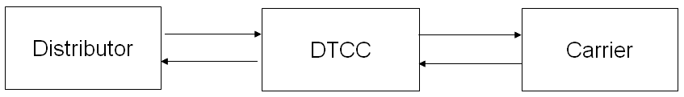

IFT- CARRIER’S IFT SYSTEM Process Flow

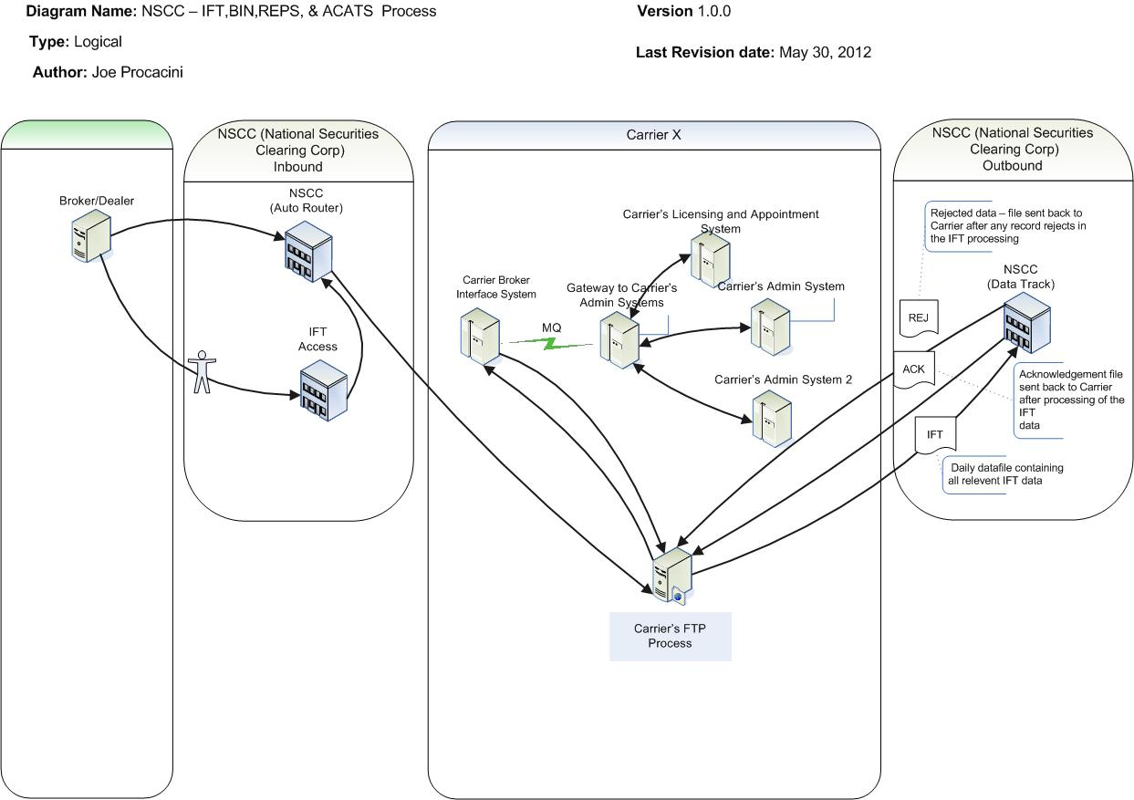

How can a distributor manage contracts already active at a carrier?
Distributors need the ability to manage the process of adding and changing Reps on a contract, and also need the ability to add, change and remove client account numbers from their annuity contracts and life policies which the carriers hold. This process has been automated by the distributor sending either a “REP’ or “BIN” transaction to the carrier via the DTCC. The NSCC formats are understandable to Carrier X once it is received, and this data has been edited for accuracy via the DTCC rules, and only validated data is received.

Carrier X can either 'Confirm' (we have processed the request) or 'Reject' (we have not processed the request. As an example if a carrier were to receive a request to change the rep on a contract and that rep was not appointed by the carrier then a rejection would go back to the distributor informing them that the transaction rejected and providing them the reason of Not Appointed.

The Benefits of IFT
  - It helps reduce manual process and eliminate paperwork (e.g. Faxes, WEW processing – scanning, imaging, document typing, assigning, etc).

  - Automation and standard formats improve accuracy (e.g. Do not have to manually manipulate, which may cause errors) and simplify processing.

  - It is a great compliance tool for Insurance carriers and distributors.

  - It facilitates not only the processing of individual reps on contracts, but also allows for splits and teams to be placed on individual contracts

3. IFT Transaction Types
IFT files are sent from the Distributor to Carrier X (Carrier) through the DTCC. These files consist of transactions that first go through DTCC edits, then the Carrier Broker Interface System edits and finally update the carriers administration system. Each transaction on a file is telling Carrier X to take action. This action will depend on the type of transaction submitted. There are several types of transactions, but the following are the specific types of IFT transactions that Carrier X supports:
- BIN – Client Account Changes – Distributor initiated transaction requesting that a contract which they control, have its “BIN’ changed or removed.

- REP – Rep changes – Distributor initiated transaction requesting to remove the rep or reps on a given contract and to place the rep or reps along with any team information on a given contract.

- CAT – Customer Automated Transfer – transaction used to report a change of a distributor to an new distributor (used in conjunction with the ACAT process) *** Not addressed further in this document.

- BEN – Beneficiary Change Transaction Request – Transaction used to report a change of Beneficiary (used in conjunction with the ACAT process) *** Not addressed further in this document.

- TEX – Time Out Transactiont – A transaction generated by DTCC indicating that the CAT and all associated transactions have been outstanding too long and are now dead (used in conjunction with the ACAT process) *** Not addressed further in this document.

4. IFT Record Layout Structure
IFT Records
When a distributor sends in a transaction on a file, that transaction will consist any and potentially all of the allowable transactions(REP/BIN/BEN/CAT/TEX).
The following are the 'Record Types' that Carrier X supports (i.e. take in and do something with):
- 7301 – 'Contract Record': Details the Transaction Type, Transaction Status and Contract level information being requested to change by this transaction (e.g. Contract number, IRS Qual Code, Apt State, etc.).

- 7304 – 'ACAT Control Record’: Details the ACAT information for this transaction if the transaction is a result of the ACAT Process

- 7310 – 'Contract Entity’: Details the Owner Information.

- 7312 – 'Contract Entity Address Record': Details the Address of the Owner if provided by the ACATS System.

- 7313 – 'Contract Entity Communications Record': Details Communication details for the Owner of provided by the ATATS system.

- 7320 – ‘Beneficiary Record’: Details information about the Beneficiary to be replaced on the contract as a result of a Broker-to Broker Transfer (ACTA Processing).

- 7322 – 'Beneficiary Address Record': Details information about the Beneficiary’s Address to be replaced on the contract as a result of a Broker-to-Broker Transfer (ACTA Processing).
- 7323 – 'Beneficiary Communications Record': Details information about the Beneficiary Communication information to be replaced on the contract as a result of a Broker-to-Broker Transfer (ACTA Processing).

- 7330 – 'Agent Record': Provides the Agent/Agents or Team information being requested to change for this contract.

4.1 Required Vs Optional Records by Transaction

Record/Transaction | 7301 | 7304 | 7310 | 7312 | 7313 | 7320 | 7322 | 7323 | 7330
CAT | Req | Req | Req | Req | Opt | Req | Opt | Opt | Opt
REP Non-standalone | Req | Req | N/A | N/A | N/A | N/A | N/A | N/A | Req
BIN Non-Standalone | Req | Req | N/A | N/A | N/A | N/A | N/A | N/A | N/A
BEN | Req | Req | N/A | N/A | N/A | Req | Opt | Opt | N/A
TEX | Req | Req | N/A | N/A | N/A | N/A | N/A | N/A | Req
REP - Standalone | Req | N/A | N/A | N/A | N/A | N/A | N/A | N/A | Req
BIN - Standalone | Req | N/A | N/A | N/A | N/A | N/A | N/A | N/A | Req

Important Note: The NSCC Control Number will appear on position 6-25 of each Record. This uniquely identifies each Transaction.

The complete IFT Record Layout Structure is available on the DTCC website, and also in the VERTEX Data Dictionary.

5. IFT Transaction Query Research Screen

- Due to the nature and importance of these transactions it may be beneficial to maintain the transactions in their state as received, along with an indication of what stage in the lifecycle they are.
- Potential Stages:
  - Received from DTCC
  - Passed preliminary edits and and sent to the licensing system for inquiry
  - Sent to the Administration system for update
  - Received by the Administration system successfully processed
  - Received from the Administration system with rejections
  - Send to the DTCC

6. Sample IFT Business Rule Requirements

Standalone BIN Rule Requirements

  - The Contract must be found on the administration system
  - The Distributor requesting the change must be the Distributor on the contract
  - The Contract Status must be and active status, and needs to be in a status in which changes to the contract are allowed by the carrier (i.e some carriers do not allow any changes if the contract is in Death Claim status, or possibly on a Legal Hold)

Standalone Rep Rule Requirements

  - The Contract must be found on the administration system
  - The Distributor requesting the change must be the Distributor on the contract
  - The Contract Status must be and active status, and needs to be in a status in which changes to the contract are allowed by the carrier (i.e some carriers do not allow any changes if the contract is in Death Claim status, or possibly on a Legal Hold)

  - All agents on the Rep transaction must be appointed with the Carrier

  - All agents being requested on the REP transaction must be under the Distributor requesting the change

  - The sum of the Agent Allocation Percentage must equal to either 100% or 0%

7. IFT Inbound File, the Carrier Broker Interface System Edits
- An Inbound File is sent into Carrier Broker Interface System from the DTCC, 3 times per day, Monday through Saturday 2:00 AM to midnight. The production times are as follows: 9:30 AM EST; 2:30 PM EST and 6:30 PM EST. Three inbound files are sent to the PSE region per day, at 9:30 AM EST; 2:30 PM EST and 6:30 PM EST.

- All Inbound Files that are sent by DTCC need to pass through the Carrier Broker Interface System edits. These Carrier Broker Interface System Edits are like Business Rules or Criteria that each transaction within the file must meet, e.g: Is the Distributor set up to send these transactions?

- Transactions that fail the Carrier Broker Interface System edits (also known as 'hard rejects') will be update the Carrier Broker Interface System masterfile, and be rejected back to the DTCC at the next output cycle.

- In order for Carrier X to receive a Distributors information, they need to be sending their transaction information to DTCC at least 20-30 minutes before the time of the Inbound File cycle (to meet the set cycles).

- Each firm identifies itself on the inbound file by its 'Clearing Number' or also called 'Participant Number'. This Number appears on the 50 record, positions 4-7. The Participant Number combined with the firms Alpha Number uniquely identifies a firm.

- Once a transaction passes all the Carrier Broker Interface System Edits, the Carrier Broker Interface System will send a request to the carrier’s administration System and Licensing System. This request could ask the following:
    - Does the Producers Tax ID exist in the carrier’s Licensing database?
    - Does the producers Selling Agreement allow them to sell the product line they are requesting to sell?, e.g. If requesting to sell a fixed annuities product, is the producers Agreement Status 'Active' to sell the 'Variable Annuities' product line?.
    - Is it for the correct Legal Entity?
    - Does the Contract Exist?
    - What Status is the contract in?

8. IFT Sample Reports
There may be some reporting necessary to monitor the progress and growth of this functionality.
These types of reports may prove useful:
- NSCC IFT Incoming Transaction Volumes Report (New)
These reports are produced on a daily, weekly and monthly basis. They show the total volumes of items that were sent though the NSCC and are broken down by Firm and Transaction Type.

- Reject Volumes Report (New)
Theses reports are also produced on a daily, weekly and monthly basis. They show the total volume of transactions that did not pass the Carrier Broker Interface System edits and are broken down by: Hard Rejects/Firm/Transaction Type/Reject Reason

9. IFT Partner Testing
- If a distributor wants to use the IFT service, Carrier X will first get them to send in a number of test files in order to ensure that they are doing everything correctly (i.e. sending in the right information on the right records, etc.). The testing that Carrier X may partake with the Distributor is known as 'Partner Testing'.

- IFT testing usually takes place in the Test. Before a distributor sends a test file, ensure that the distributor is set up correctly in the test region, including entering their settings in the DTCC Portal for IFT Access Players.

- Carrier sends out test files within to the PSE region, making sure to use the correct sysid for the Datatrek process to route to the PSE region. When sending out test files make sure that all transactions within the files are only going to the distributors that we are partner testing with. If there are other distributor's 'participant' numbers on the file, then we change their participant number to that of our Dummy Dealer number which is 0122. The reason for this is that this file will get as far as the DTCC and go no further.

- Carrier will usually have a number of weekly check-in meetings with each distributor in order to update them on progress and resolve any partner testing issues.

10. Applications used to support IFT standalone REP/Bin Transactions

10.1 IFT Access
- This is a web based, online data entry tool that will allow Distributors to enter Rep and Bin Transactions. It also allows for a import process which takes a formatted spreadsheet of information and creates the appropriate transactions from that data. This service will allow Distributors to enter pre-defined required data for transaction requests.

- IFT Access was developed based on feedback from the carriers.

- IFT Access will be used by Distributors that may not have the required resources to support the full IFT service.

- Requests/Transactions sent in through IFT Access (unlike normal IFT processing) do NOT pass through DTCC edits. What values/information that Distributors are required to enter should match the DTCCs rules - but there is no double check.

- Using IFT Access will automate the IFT process, improving accuracy and simplify processing.
- For testing purposes a distributor must be added to the DTCC IFT Access service for Carrier X.
- Firms/distributors involved in IFT Access partner testing will receive a response from the carrier through NSCC in the form of an 'Import File'.
- IFT Access Distributors have to reenter all of the data for a producer should the item be rejected or should they need to send to an additional carrier.

Glossary of Terms and Abbreviations
Term | Definition
Agent or Rep | Person/Individual who is licensed to sell insurance products. Also called Producer, an Agent will usually be working for a Firm/Distributor. E.g. INVEST FINANCIAL CORPORATION: Dealer Alpha Code = INVT
Alpha Code | Each dealer or 'Parent Dealer Record' has a dealer 'Alpha' code assigned to it that, along with the Clearing Number', uniquely identifies that dealer.
the Carrier Broker Interface System | A system built by the Carrier to manage and maintain the electronic conversation between the distributor and the Carrier’s internal systems
Carrier | A Carrier is a company/organization who provides insurance products.
Clearing Number | Each dealer or 'Parent Dealer Record' has a Clearing (or 'Participant') Number assigned to it that, along with the Alpha Number', uniquely identifies that dealer.
DTCC | The Depository Trust & Clearing Corporation.
Hard Reject | A transaction that fails a the Carrier Broker Interface System edit.
Legal Entity | An individual or organization which is legally permitted to enter into a contract, and be sued if it fails to meet its contractual obligations.
MRO also known as Participant Number | Machine Readable Output. Is a unique number given to a Carrier Legal Entity or Line of Business.
NSCC (also referred to as DTCC) | National Securities Clearing Corporation. Allows for a single access point for electronic data interchange (EDI) between a carrier such as Carrier X and broker/dealers. The NSCC allows Carrier X to communicate with broker/dealers using standard formats, which increases efficiency, reduces costs and minimizes risks.
Position | This means the exact location (also called 'field' or 'column) that the data can be found on each record on a file. The positions run across the top of the file from left to right. The make it easier to identify the position of data you can type in 'cols' on the command line of the file. Please see the IFT Record Layout Structure for the positions of all data.
Producer | Person/Individual who is licensed to sell insurance products. Also called Agent, a Producer will usually be working for a Firm/Distributor.
SSN | Social Security Number. This is also called the TIN (Tax ID Number)

