A Guide to Positions New File (PNF)

Table of Contents

1. Scope and Purpose 3

2. Introduction to PNF 3

2.1 What is PNF? 3

2.2 Defining what is in the PNF file? 3

2.3 The Process around PNF 3

2.4 Why PNF? 4

2.5 Players in the PNF process 4

3. PNF/PFF Record Structure 6

4 PFF Structure 7

5 Design Considerations 7

Glossary of Terms and Abbreviations 8

1. Scope and Purpose
The scope and purpose of this document is as follows:

- Provide a basic an understanding of the PNF positions file functionality along with the information on How it is to be used
- Provide some design consideration as a Carrier begins to understand the scope and magnitude of the development effort for the creation of PNF functionality within their current Valuations extract functionality

In no way is the intention of this documentation to be an exhaustive collection of both business and technical considerations around the PNF process, but it is intended to be a starting point and spark discussion and brainstorming around the build process.

2. Introduction to PNF

What is PNF?
PNF stands for 'Positions New File'. This service is one of the formats and functionality under the overall Positions (POV) service offered by the DTCC. It was created to be the third component of the valuations functionality, which allows the carrier to provide extensive contract information to the distributor to update their “Book of Business”.

Defining what is in the PNF file?

The intention of the PNF file is that only contracts which are New to the Distributor, are to be included in the PNF file. By new to the distributor it means:
- Contracts which have been issued during the last cycle
- Contracts which have been transferred to the Distributor during the last cycle
Contracts which are new to the distributor are as a result of either and ACAT (Automated Customer Account Transfer (a service provided under the DTCC which facilitates the automatic re-registering of assets to a receiving Broker Dealer from a Delivering Broker Dealer), or as a result of a contract owner informing the Carrier that he/she wants their contract move to a different Distributor.

The Process around PNF

PNF as a file structure was not intended to be a full update of the contract information on a distributor’s base, but instead was intended to be supplemented with the creation of a PFF (Focused) valuation file. The intention is that the distributor would first update his books with all “New” contracts which are as a result of the Carrier’s last cycle, then they would use the PFF (Focused) file to update all the contracts (both new and old) with the values which have been transmitted in theis file.

Why PNF?

PNF was created initially as a way for the carrier to limit the processing time, and transmission time needed to initially create a PVF (Full Refresh) on a daily basis. The intention was that a distributor would request a PVF (Full refresh) at the start of the month, and then would receive the PNF (new Contracts) and PFF (Refresh) on a daily basis until the end of the month when a PVF (Full Refresh) would be sent.

The process has been slightly modified so that some distributors request a PNF/PFF combination Monday – Friday, and a PVF over the weekend.

2.5 Players in the PNF process

- (National Securities Clearing Corporation)
The NSCC (also called 'DTCC') is a clearing corporation that makes it easier for Carriers and Distributors to exchange 'information'.

- Carrier
A Carrier is an organization that provides Insurance/Annuity products, e.g. Carrier X. Within Carrier X there are a number of 'Legal Entities'; Carrier X US , Carrier X NY and Carrier X Life . Each Legal Entity is assigned an MRO number (Carrier X US – 4991; Carrier X NY – 4991; & Carrier X Life – 4992).

- Distributor
Carrier X needs somebody to sell their products. A Distributor (also called a 'Firm') is an organization that sells Carrier X’s Insurance/Annuity products.

A distributor will have 'producers' or 'agents' out in the field selling Carrier X products. Merrill Lynch and Morgan Stanley are just some examples of Distributors that sell products for Carrier X.

Distributors maintain systems either developed in house, or purchased via a Clearing Firm which facilitate the management of a “book of Business for their reps.

- Producer
A Producer (also called 'Agent' or ‘Rep’) is an individual that sells Carrier Xs Insurance/Annuity products 'basically a 'sales person'. Each Producer will usually be working for a 'Distributor' (also called a 'Firm').
.
- Why does Carrier X use PNF?
Carrier X uses the PNF service to facilitate the updating of the distributor’s systems with “New” full contract information changing and removal of both Representatives, and BIN’s from active contracts which the Distributor owns and controls.

POV- CARRIER’S Valuation Generation Process Flow

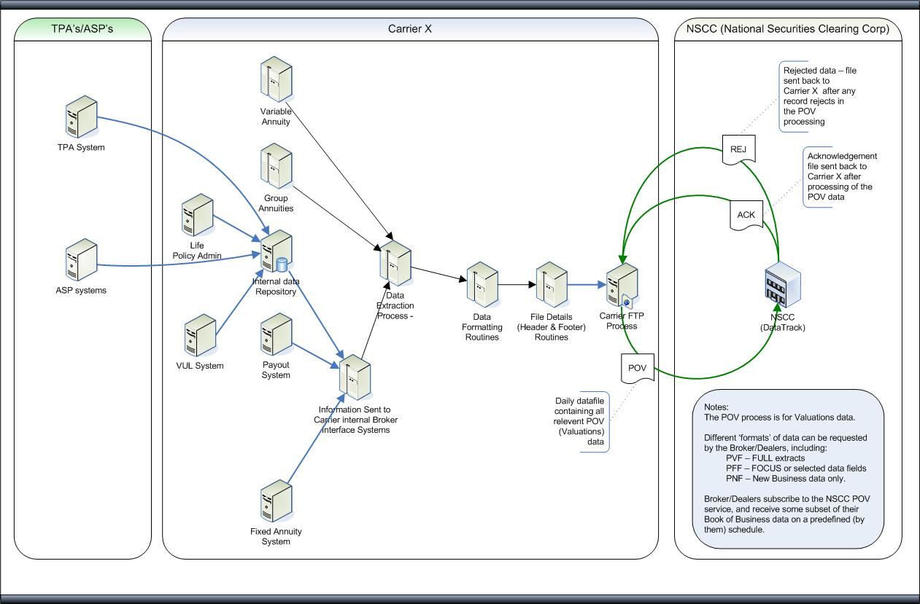

The Benefits of IFT
  - It helps reduce processing time at the carrier
  - It reduces the transmission time by reducing the amount of records being sent
  - It identifies for the distributor the contracts which are new as of the last cycle, enabling them to add them to their “book of business”

3. PNF/PFF Record Structure
PNF Structure
The PNF structure is identical to the PVF (Full Refresh) record structure with the exception of the IPS Event Code (item 1002) on the Contra Record (12) contains “PNF” identifying that this is a PNF file to the distributor

10 - Submitting Header - Mandatory - 1 - occurrence required for each file.
12 - Contra Header - Mandatory - 1 - occurrence for each contra party sent.
13/Seq01 - Contract Record - Mandatory - (99,999,999 occurrences per Contra Header, at least one is required.)
13/Seq02 - Contract Valuation Record - Optional - (20 occurrences per Contract Record)
13/Seq03 - Contract Underlying Assets Record - Optional - (999 occurrences per Contract Record)
13/Seq04 - Contract Band/Guaranteed Loop with Underlying Assets Record - Optional -
(999 occurrences per Contract Underlying Assets Record) (If 13/04 is present, then 13/03 is required)
13/Seq05 - Contract Agent Record - Optional - (25 occurrences per Contract Record)
13/Seq06 - Contract Dates Record - Optional - (1 occurrence per Contract Record)
13/Seq07 - Contract Events Record - Optional - (2 occurrences per Contract Record)
13/Seq09 - Contract Party Record - Optional - (99 occurrences per Contract Record)
13/Seq10 - Contract Party Address Record - Optional - (1 occurrence per Contract Party Record)
13/Seq11 - Contract Annuitization Payout Record - Optional - (10 occurrence per Contract Party Record)
13/Seq15- Service Feature Record - Optional - (99 occurrences per Contract Record)

PFF Structure
The PFF structure is has records which are identical to the PVF (Full Refresh) and PNF (New) record structure but does not allow for all record types. The other exception is the IPS Event Code (item 1002) on the Contra Record (12) contains “PFF” identifying that this is a PFF file to the distributor

10 - Submitting Header - Mandatory - 1 - occurrence required for each file.
12 - Contra Header - Mandatory - 1 - occurrence for each contra party sent.
13/Seq01 - Contract Record - Mandatory - (99,999,999 occurrences per Contra Header, at least one is required)
13/Seq02 - Contract Valuation Record - Optional - (20 occurrences per Contract Record)
13/Seq03 - Contract Underlying Assets Record - Optional - 999 occurrences per Contract Record)
13/Seq04 - Contract Band/Guaranteed Loop with Underlying Assets Record - Optional -
(999 occurrences per Contract Underlying Assets Record) (If 13/04 is present, then 13/03 is required)
13/Seq07 - Contract Events Record - Optional - (2 occurrences per Contract Record)

5 Design Considerations
- The POV file can contain all the different types within the stacked file. This means that if a Distributor wants a PVF, and another wants a PFF, and still another wants a PNF within a given Carrier’s Participant Number then the file could be structured as so:

Record Type

10 – Submitting Carrier
12 – Contra Header Distributor 1 PVF file
13-01 – 13-15 records
12 – Contra Header Distributor 2 PFF File
13-01 – 13-07 records
12 – Contra Header Distributor 3 PNF File
13-01 – 13-15 records (new only)
12 – Contra Header Distributor 3 PFF File
13-01 – 13-07 records (all contracts)

- Given that the Distributor can and will ask for different types of valuations on different days, this process lends itself to the development of a calendaring function by distributor allowing for different formats to be requested on different days by different distributors

- From an efficiency prospective it will be beneficial to do a complete extract from your admin systems of all contracts for all distributors who are requesting valuation information for a given day. This information can then be processed in a “Formatter” which can look to the individual type of distributor and see the type and format of records to be included in the output file to be sent to the DTCC.

Glossary of Terms and Abbreviations
Term | Definition
Agent or Rep | Person/Individual who is licensed to sell insurance products. Also called Producer, an Agent will usually be working for a Firm/Distributor. E.g. INVEST FINANCIAL CORPORATION: Dealer Alpha Code = INVT
the Carrier Broker Interface System | A system built by the Carrier to manage and maintain the electronic conversation between the distributor and the Carrier’s internal systems
Carrier | A Carrier is a company/organization who provides insurance products.
Clearing Number | Each dealer or 'Parent Dealer Record' has a Clearing (or 'Participant') Number assigned to it that, along with the Alpha Number', uniquely identifies that dealer.
DTCC | The Depository Trust & Clearing Corporation.
Legal Entity | An individual or organization which is legally permitted to enter into a contract, and be sued if it fails to meet its contractual obligations.
MRO also known as Participant Number | Machine Readable Output. Is a unique number given to a Carrier Legal Entity or Line of Business.
NSCC (also referred to as DTCC) | National Securities Clearing Corporation. Allows for a single access point for electronic data interchange (EDI) between a carrier such as Carrier X and broker/dealers. The NSCC allows Carrier X to communicate with broker/dealers using standard formats, which increases efficiency, reduces costs and minimizes risks.
Position | This means the exact location (also called 'field' or 'column) that the data can be found on each record on a file. The positions run across the top of the file from left to right. The make it easier to identify the position of data you can type in 'cols' on the command line of the file. Please see the IFT Record Layout Structure for the positions of all data.

