Creating Rate Tables in VTXml
Updated March 15, 2011

The procedures below document the steps to create a Rate Table in VTXML. In order to do this, the user will have to create 2 separate items:
- Creating the Table Definition – Step by step explanation to create the rate table name, KeyDef and AxisDef information. These items are used in the PPfA XTbML Content Classification and MetaData.
- Creating the Table Values – Step by step explanation to create the rates associated with the KeyDef and AxisDef. These items are used in the PPfA XTbML ‘Values’.

Best Practices:

- Check to see if there is an existing rate table which can be reused. There is no need to rebuild a rate table.
- Find a naming convention which will allow you to reuse rate tables.
- Use the Table Definition page to update existing Table Names (if needed) to make it easier to read and associate to your Commission Schedules.
- Appendix A is an example of how to use the KeyDef to create a conflict between a Feature Option and a Commission Option.
In this example, the user wants to restrict an option if a specific feature option (i.e. Rider1) is selected on the policy product. (i.e. the option is not available if Rider1 is selected on the policy product). However, Rider2 and Rider3 are not restricted.
Since there is no way to ‘restrict’ feature options on a rate table, we must look at this deliverable from a different approach. That approach is to create the rate table so that it is ‘inclusive’ instead of ‘restrictive’.
In other words, the rate table is created to include the riders that are allowed (i.e. Rider2 and Rider3) in the KeyDef. This way, when Rider1 is selected on the product, the option is not allowed because it is not included in the KeyDef.

Create the Table Definition
- Click on ‘Table Definitions’ from the left nav
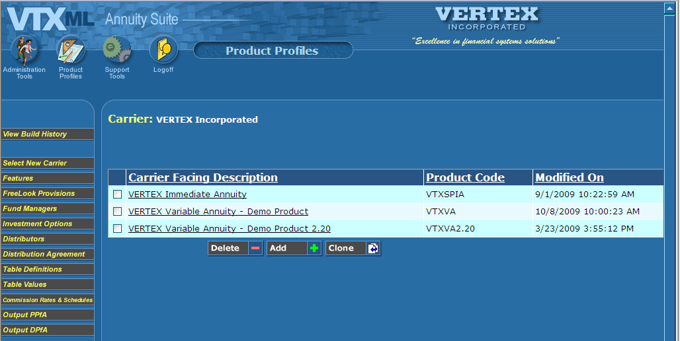

- Click ‘Add’ to add a table definition
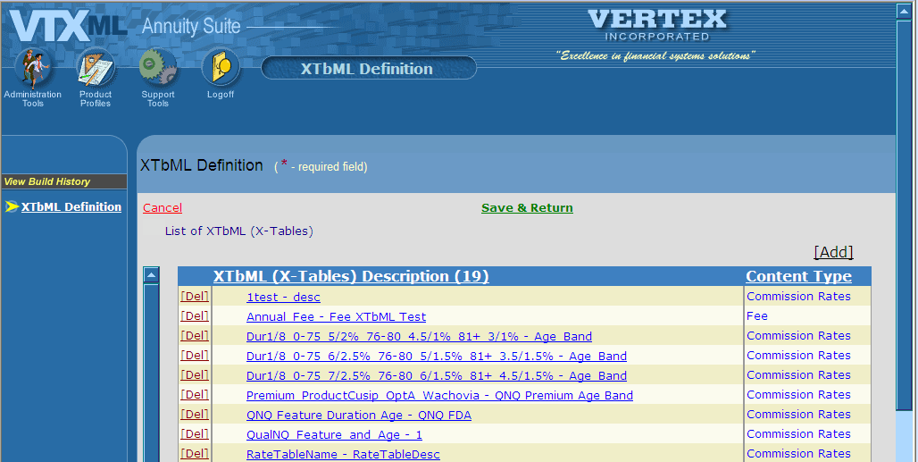

- Create a Name for the rate table.
  - The rate table name must not include spaces! Use ‘_‘(underscore) to indicate a space.
  - Rate tables typically fall into 2 categories.
    - Rates that are generic for all products (i.e. banded and non banded rates) and
    - Rates for specific products and/or distributors. Rates for specific products and/or distributors should provide enough information to easily distinguish them from other rates. For example, a rate based on minimum premium, for Wachovia, Product A, Option A could be named ‘Premium_ProductCusip_OptA_Wachovia’.
    - Examples of rate table definitions:
      - 0-80:_5.00%_81-99:_2.50% for age banded rate
      - NoBanding_2.75% for non banded rate
      - Premium_ProductCusip_OptA_Generic for specified rate
- Add a description - The description is user defined. It should explain the type of rates i.e. Age Band
- Include a comment (Optional) - If more detail is needed about how the rates will be used. Platforms are not currently doing anything with this property.
- Select ‘Commission Rates (53)’ or ‘Fee (66)’ in the Content Type list box.
- Click ‘Add’ in the ‘List of Tables’ popup box. This popup box is used to add the KeyDef and AxisDef.
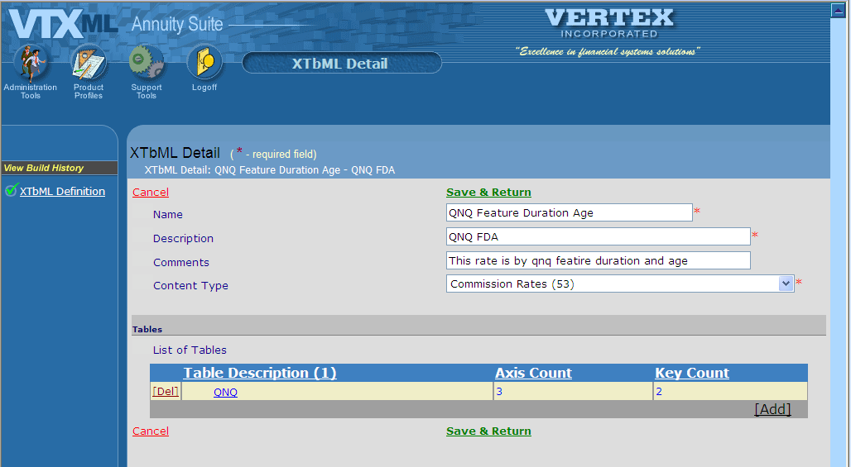

Create the KeyDef and AxisDef Detail:
- Add a description: - The List of Tables will vary upon the type of XTbML detail. The description should be created to include information regarding all tables. For example, if the table was for age banded rates only, the Table Description would be ‘Age Band’. The table below provides some examples of common Table Descriptions that are used.
Description Names | Used for:
Age Band | Rates based upon age banding
No Banding | Rates were no banding is specified
Premium | Rates based upon minimum premium
Premium and Age Band | Rates based upon premium and age banding
Duration | Rates based upon duration
Duration and Premium | Rates based upon duration and premium
QNQ Premium and Age Band | Rates based upon Qualified/Nonqualified, premium and age banding

- Add a scaling Factor – This will always be ‘0’.
- Include a data Type – This field should always be set to ‘Percentage (20)’.
- Select the currency - ‘US Dollar (USD)’ – (This is optional).
- Select the nation – US - (This is optional).
- Specify the jurisdictions - The Jurisdictions box is used to restrict the rates to specific jurisdictions, if needed. To restrict a rate by jurisdiction, scroll through the list of Jurisdictions and click on the jurisdiction(s) that apply to the rate.
- Complete the KeyDef Popup – KeyDefs are used to define non ordered rate variations, e.g. QNQ, Feature, Fund, etc… KeyDef is contained in the XML MetaData aggregate. Click this link for procedures to add a KeyDef,
- Complete the AxisDef Popup - AxisDefs are used to define ordered rate variations, e.g. for Age, No Banding, Premium, Duration, Date, etc… AxisDef is contained in the XML Values aggregate. Click this link for procedures to add an Axis Def.
Create the KeyDef:
- Click ‘Add’ in the KeyDef popup box to add KeyDef.
- Click ‘OK’ to the warning ‘All table values will be deleted if you add this dimension. Are you sure you want to add?’
- Type in a Key Name to describe the KeyDef. For example, a KeyDef based upon a Feature would be named ‘Feature’
- Type in a Dimension Sequence. This is a consecutive number always beginning with ‘1’. The sequence MUST increment by 1 across both KeyDef and Axis Def and be unique for each rate table. (see Step 7)
- Select a Key Type from the drop down list box. Key Type, Key Sub Type, Key Sub Class Type, Key Sub Class and Key Code Type fields are used together to define the KeyDef.
- If Key Type is a string, you must specify a Key Sub Type, Key Sub Class Type and Key Sub Class fields. This is the Enumerated String Value in the PPfA MetaData.
- If Key Type is a type code, you must select a Key Code Type from the dropdown. This is the EnumeratedTypeCodeValue in the PPfA MetaData.
- Select a Key Sub Type from the drop down list box – This should always be ProductCode (21)
- Select a Key Sub Class Type from the drop down list box: 32 = Sub Account, 86 = Annuity Rider, or 89 = Arrangement.
- Select a Key sub class from the drop down list box. Select the FeatureCode from the dropdown – this is only used when the rate needs to vary by FeatureOption.
- Select a Key Code Type from the drop down list box. Select the Lookup table the rate should vary. This should only be used if the KeyType = 1 TypeCode.
- Click ‘Add’ in the Key Values Popup. There must be at least 1 Key Value created. The value can be a string that defines several key values i.e. 1, 2 or if the key type is a code, the value must exist within the product (i.e. the investment product code such as ‘005 or 007’. The table below is a guide to creating a KeyDef based upon a Feature and Qualified/Nonqualified.
- Click Save & Return to save the KeyDef Values
- Click Save & Return to save the KeyDef and return you to the XTbML Detail page.

Key Name | Feature | QualNonQual
Dimension Sequence | 1 | 2
Key Type | Key is a String (2) | Key is a Type Code (1)
Key Sub Type | Product Code (21) | N/A
Key Sub Class Type | Feature Opt Product (86) | N/A
Key Sub Class | LSR | N/A
Key Code Type | N/A | Qualified Code (1062)
Key Values Popup | 1…* values (005, 007) | 1..* values (1, 2)

- This is an example of a Feature KeyDef
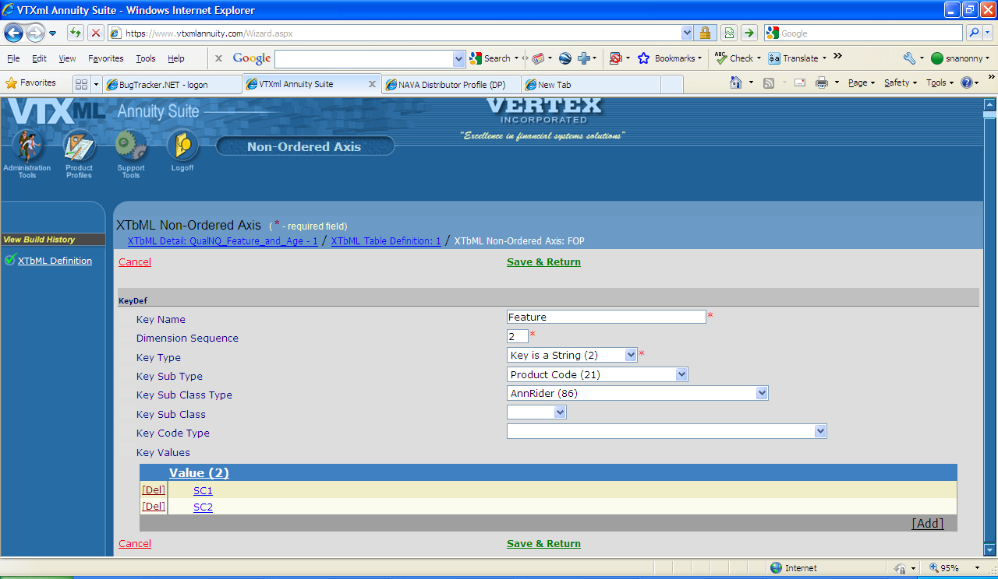

- This is an example of a String value (for Feature)
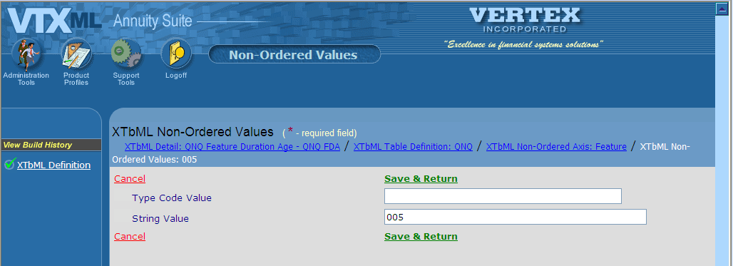
- This is an example of a Qualified/Not Qualified KeyDef

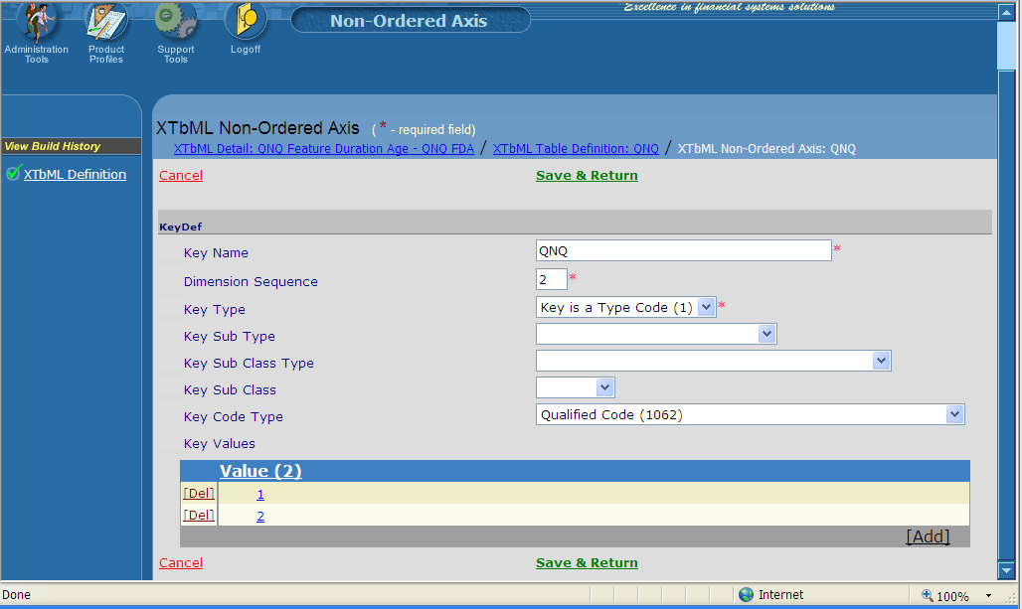
- This is an example of a Type Code value (for QNQ)

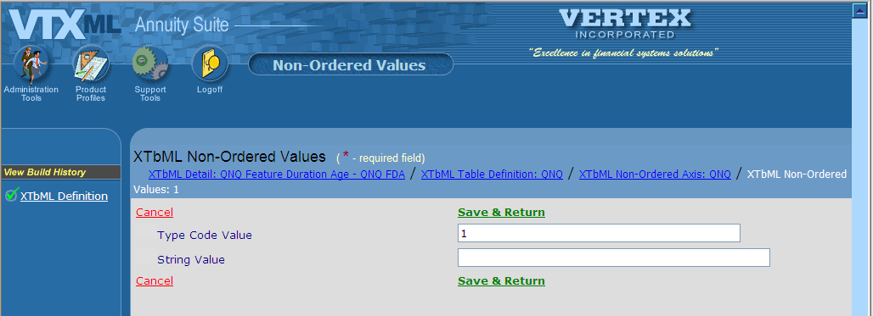

Create the AxisDef:
- From the XTbML Detail page, click ‘Add’ in the AxisDef popup box.
- Click ‘OK’ to the warning ‘All table values will be deleted if you add this dimension. Are you sure you want to add?’
- Type in an AxisDef Name to describe the AxisDef. For example, an AxisDef based upon Age would be named ‘Age’.
- Select a Scale Type from the drop down list box.
- Select a Scale Sub-Type from the drop down list box.
- Type in an Increment Value – ‘1’.
- Type in a Dimension Sequence.
- If there are no KeyDef defined, then the first AxisDef dimension sequence should be ‘1’
- If there are KeyDef defined, then the AxisDef dimension sequence should be the next number. For example, there are 2 KeyDefs with the dimension sequence 1 and 2. Therefore, the first AxisDef dimension sequence should be ‘3’.
- If the Rate varies by Duration then select a Mode from the drop down list box according to the scale type, see the table below
- If the Rate varies by Premium then select a Banding type from the drop down list box according to the scale type, see the table below
- Select Yes or No from the Continuous drop down list box according to the scale type, see the table below.
- Click ‘add’ from the Ordered Values popup box to add values.
  - Type in an Axis Value. Click Save & Return. Repeat this step for each Axis Value.
- The table below shows 4 common AxisDef and their corresponding values.
VTXML Field Name | Age | No Banding | Duration | Premium
Scale Type | Age (3) | Unknown (0) | Ordinal Date – units of time i.e. years, months, days (2) | Premium Amount (5)
Scale Sub-Type | Issue Age (1) | Unknown (0) | Contract Duration (15) | Gross cumulative premium (18)
Min Scale Value | 0 | N/A | N/A | N/A
Max Scale Value | 90 | N/A | N/A | N/A
Min Scale Date | N/A | N/A | N/A | N/A
Max Scale Date | N/A | N/A | N/A | N/A
Increment Value | 1 | 0 | 1 | 1
Dimension Sequence | 4 | 1 | 3 | 5
Mode | N/A | N/A | Annual (1) | N/A
Banding Type | N/A | N/A | N/A | Simple Banding (1)
Continuous | Yes | No | Yes | Yes
Ordered Values Popup | 0, 76 | -9999 | 1, 2, 3, etc | 0, 10000

- This is an example of an AxisDef based upon ‘Age’

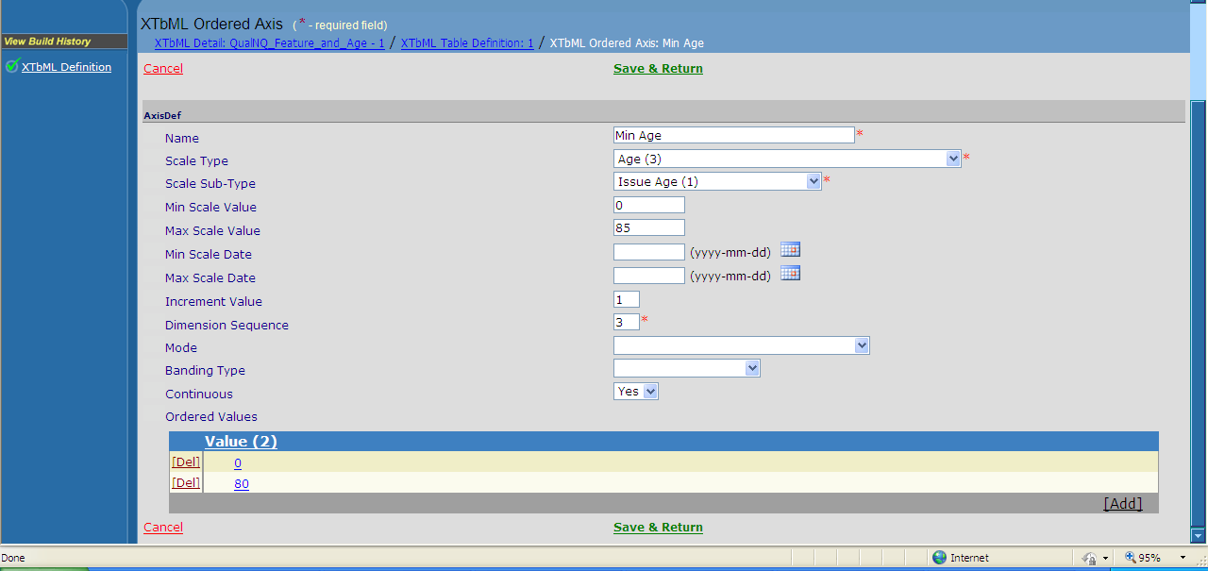

- This is an example of an AxisDef Axis value
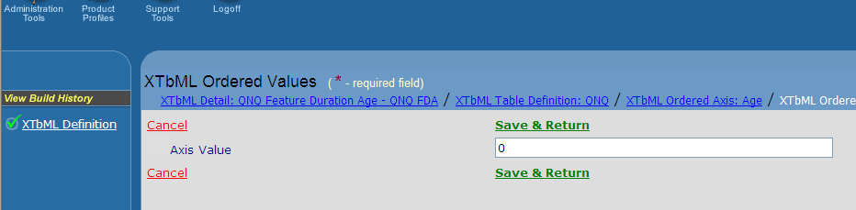

Create the Table Values
- Click on ‘Table Values’ in the left nav
- Scroll the list of Rate Table Names, and then click on the table created in the previous steps.

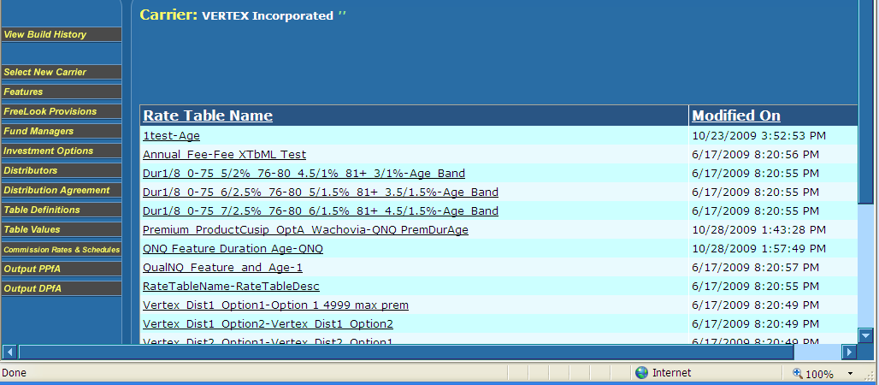

- VTXML displays a screen that has the KeyDef and Axis Def criteria created in the Table Definitions. Scroll through the page and type in the appropriate rates that apply to each KeyDef and AxisDef.
- Click Save when all rates have been entered.

Appendix A
Deliverable:
Distributor ABC has 3 commission options: Option A, Option B and Option C. All 3 commission options are based upon the feature options that are selected on the policy product. Option A does not allow commissions for Rider1. The table below shows the commission options:

Feature Option Option A Option B Option C
Rider1 Not Allowed Allowed Allowed
Rider2 Allowed Allowed Allowed
Rider3 Allowed Allowed Allowed

In this example, Option A is not available if Rider1 is selected on the policy product (i.e. the user wants to restrict ‘Option A’ if Rider1 is selected). However, Rider2 and Rider3 are not restricted on Option A.
Since there is no way to ‘restrict’ feature options on a rate table, we must look at this deliverable from a different approach. This approach is to create the rate table so that it is ‘inclusive’ instead of ‘restrictive’.
In other words, the rate table is created to include the riders that are allowed (i.e. Rider2 and Rider3) in the KeyDef. This way, when Rider1 is selected on the product, the option is not allowed because it is not included in the KeyDef.

Solution:
- Create a rate table for Option A that has a KeyDef and include the Riders that were not restricted (Rider2 and Rider3). You can use the ‘Description’ to The KeyDef looks like this:
- Key Type = String (2)
- Key Sub Type = Product Code (21)
- Key Sub Class Type = AnnRider (86)
- Key Sub Class = CDSC
- 2 Enumerated Values = ‘Rider 2’ and ‘Rider 3’ (for the Riders that are allowed)
- Create rate tables for Option B and Option C that has a KeyDef and include the Riders that were not restricted (Rider1, Rider2 and Rider3). The KeyDef looks like this:
- Create a commission schedule for the distributor with 3 Options: Option A, Option B and Option C.

This is a screen print of the Rate Table that excludes Rider1. You can use the Description to inform the user that Rider1 is excluded from the rate table.
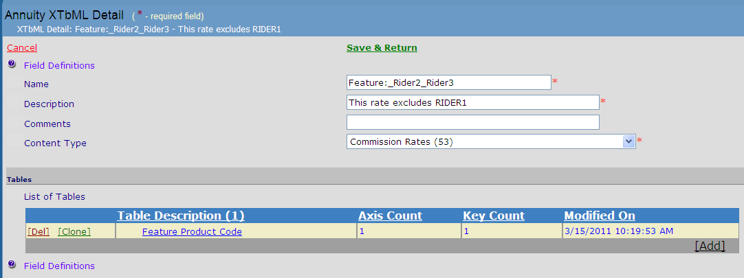

This is a screen print of the Table Definition to show the Axis with both the KeyDef and the AxisDef already created.
It is important that the Dimension Sequence are unique and consecutively numbered.
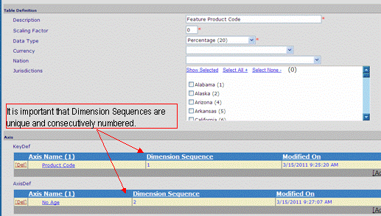

This is a screen print of the KeyDef.
The ‘Key Sub Type’ and ‘Key Sub Type Class’ are used together for a rate table that requires specific features options are selected on the policy product. It can require 1 or more feature options. In this example, the feature options ‘Rider2’ and ‘Rider3’ are allowed when this rate table is selected on Option A.
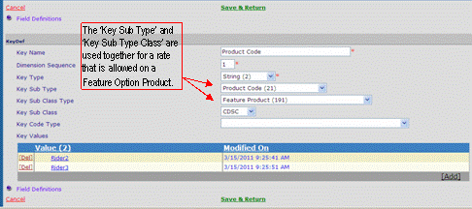

Below are snippets from the ppfa to show the rate that ‘excludes’ Rider1.

This is a snippet of the PolicyProductInfo (/TXLife/TXLifeRequest/OLifE/DistributionAgreement/PolicyProductInfo):
<PolicyProductInfo>
<PolicyProductInfoKey>PPI4555</PolicyProductInfoKey>
<ProductCode>YourProductCodeHere</ProductCode>
<CarrierCode>99999</CarrierCode>
<NettingAllowedInd tc="1">True</NettingAllowedInd>
<DefaultCommCode>2</DefaultCommCode>
<AdvancingAllowedInd tc="0">False</AdvancingAllowedInd>
<CommScheduleCode>CS6147</CommScheduleCode>
<CommOptionAvailable>
<CarrierCommCode>2</CarrierCommCode>
<CommOptionDesc>Option A (not available w/ Rider1)</CommOptionDesc>
<CommOptionName>Option A (not available w/ Rider1)</CommOptionName>
</CommOptionAvailable>
</PolicyProductInfo>

This is a snippet of the XTbML (/TXLife/TXLifeRequest/XTbML):
<XTbML id="CC6590 ">
<ContentClassification>
<TableIdentity>CC6590</TableIdentity>
<ProviderDomain>YourProviderDomainNameHere</ProviderDomain>
<ProviderName> ProviderNameHere.</ProviderName>
<ContentType tc="53">Commission Rates</ContentType>
<TableName>No_age_banding_6.00%_CDSC</TableName>
<TableDescription>CDSC</TableDescription>
<Comments>CDSC</Comments>
</ContentClassification>
<Table>
<MetaData>
<ScalingFactor>0</ScalingFactor>
<DataType tc="20">Percentage</DataType>
<TableDescription>No banding CDSC</TableDescription>
<KeyDef id=“_db11e4de">
<KeyType tc="2">String</KeyType>
<KeySubType tc="21">Product Code</KeySubType>
<KeySubClassType tc="86">AnnRider</KeySubClassType>
<KeySubClass>CDSC</KeySubClass>
<KeyName>Feature</KeyName>
<DimensionSequence>1</DimensionSequence>
<EnumeratedStringValue>Rider2</EnumeratedStringValue>
<EnumeratedStringValue>Rider3</EnumeratedStringValue>
</KeyDef>
</MetaData>
<Values>
<Key KeyIs="Rider2" KeyDefID=“_db11e4de">
<Y>6</Y>
</Key>
<Key KeyIs="Rider3" KeyDefID=“_db11e4de">
<Y>6</Y>
</Key>
</Values>
</Table>
</XTbML>

