February 22, 2012 VTXml Release

1) Add Version to Distributors.

We have added Version to the Distributor page. Carriers need the ability to associate a Distributor to multiple Versions in order to migrate from one platform version to another (e.g. ANW to AN3).

Prior to this release a Distributor was only associated to a single Intended Receiver. Carriers could not specify a Version nor could they associate to multiple Intended Receivers. Typically Merrill Lynch and a handful of Pershing firms had to be duplicated to allow for an Ebix Version and an Aplifi Version.

We have combined the Intended Receiver and Version to solve for both of these issues.

VTXml took the value which was in the Intended Receiver dropdown and moved it to the checkbox list using the following logic:
- If Ebix then set to Ebix 2.16 except when the OrgCode is Edward_Jones then set to Ebix 2.22.
- If Aplifi then set to Aplifi 2.20 except when the OrgCode is SMITHBARNEY then set to Aplifi 2.16.

Distributor page:

Version is now included in the Intended Receiver column along with all of the variations associated to that specific Distributor.

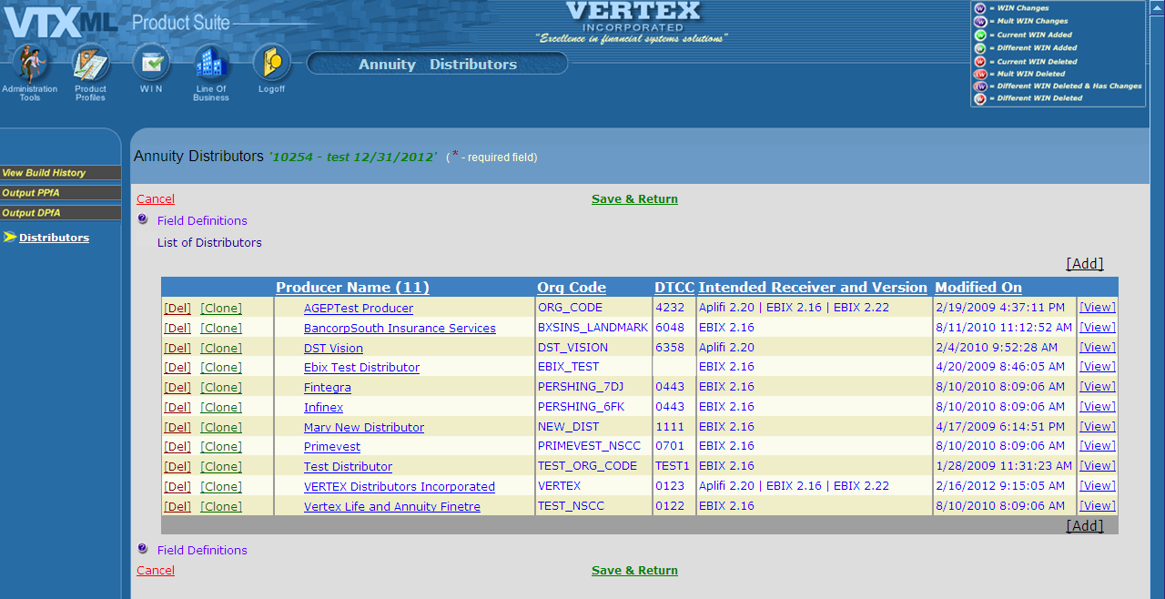

Distributor Detail page – Intended Receiver:

The Intended Receiver Dropdown has been replaced with a new checkbox list allowing multiple Intended Receiver and Version combinations. This list is generated based on the Version(s) specified on the Carrier/Writing Company page and the VERTEX maintained list of Intended Receivers/Versions. If a Carrier only allows Version 2.20 then they will only see Aplifi 2.20 as Aplifi is the only Intended Receiver associated with 2.20.

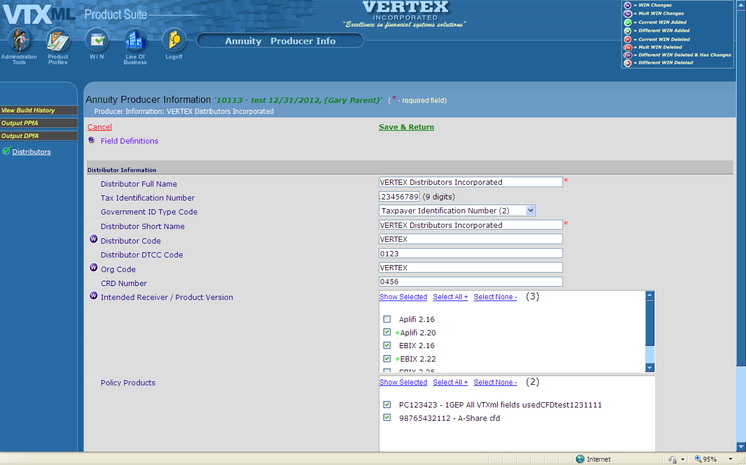

DP output page:

The DP output page has also been updated and will only show Distributors who meet the user specified Version and Intended Receiver selections. For example, Ebix 2.22 will only return Distributors who have Ebix 2.22 specified on their Distributor page.

If there are no Distributors associated with a specific Version and or Intended Receiver then a grayed out checkbox stating “No Producers Found – 0 Policy Product(s)” will be returned.

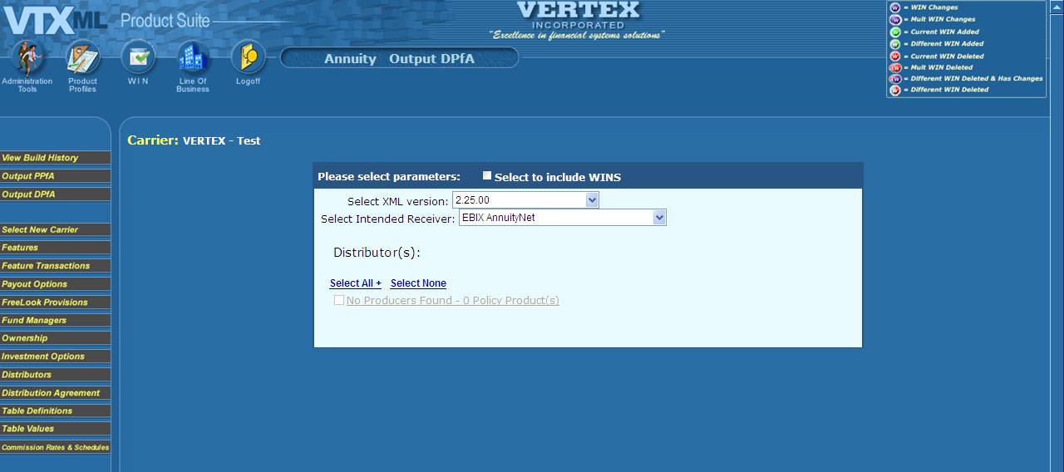

Carrier Impact:

Carriers will need to review their Distributors to ensure they are on the correct Intended Receiver and Version. This is especially important for the Carrier Test Distributors as prior to this change there was a single Test Distributor for all Versions. Now you will need to add the applicable Version(s) for the test Distributor.

Also Carriers can now consolidate the Merrill Lynch and Pershing firms to a single instance for use on both AnnuityNet and Affirm. Carriers may have to add additional CarrierAppointments if you have different OrgCodes for each platform.

Best Practices – adding or removing a version to a distributor will need to be cleaned up right away. The work flow should be as follows:
- Open a new WIN
- Add/remove the additional Version(s) to the Distributor
- Associate to additional Products if needed
- Add Carrier Appointments if needed
- Cleanup the WIN

There is no reason to manage these changes in a WIN.
2) Add ability to Archive Products and Features.

VTXml has been enhanced to allow users to hide or show Products and Features. This functionality is being added to mainly support AMP as Carriers are having to add past Products and Features to VTXml which will rarely need to be updated. To lessen the clutter on the screen new dropdown has been added to the main Product Profiles screen and main Feature page called Archive Indicator. The options will be Yes or No and this will be a required field. We will default all Products and Features to No, meaning Production.

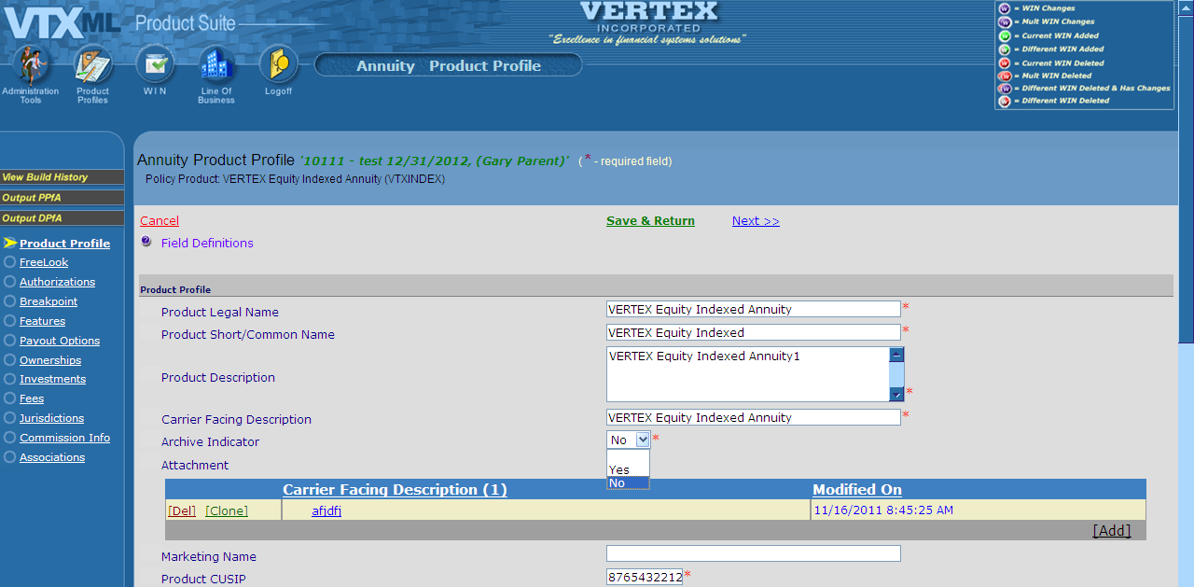

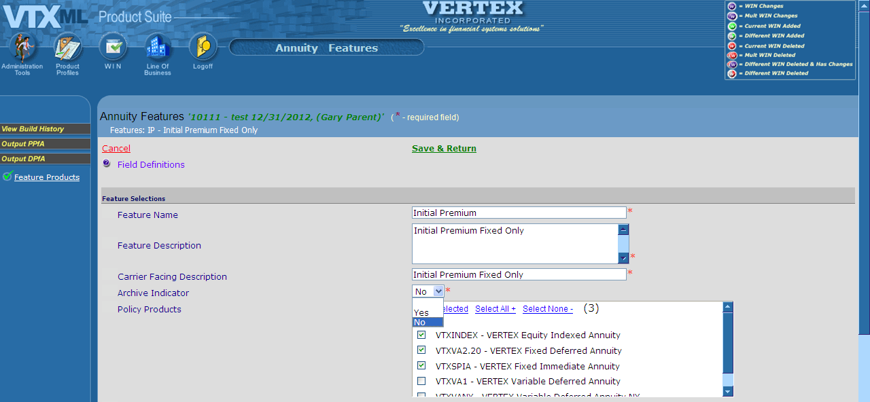

The Product page now has two additional checkboxes called Production (defaulted) and Archive. Production will show all Products which have the Archive Indicator set to No. Archive will show all Products which have the Archive Indicator set to Yes. If both checkboxes are checked, ALL Products will be displayed. If neither checkbox is checked then no Products will be displayed.

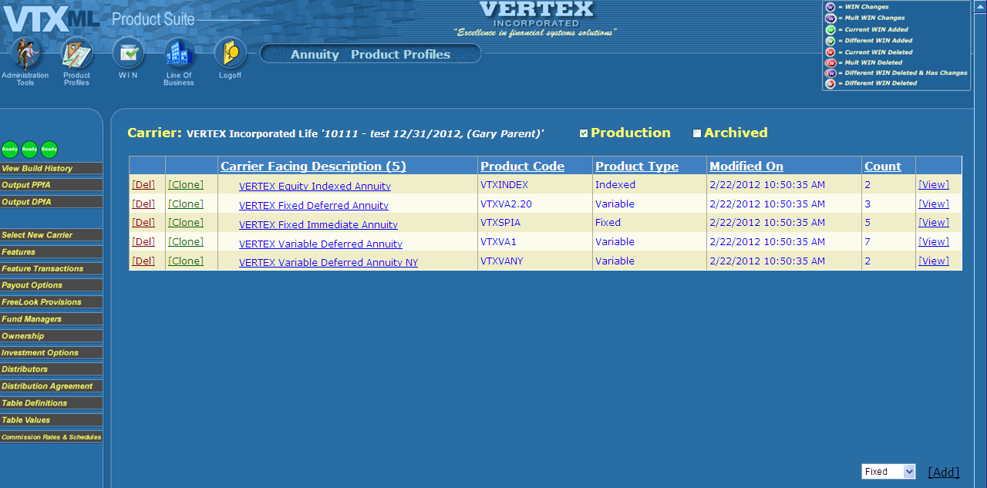

The Feature page has been updated to now include a new popup at the bottom of the page called Archived Feature Products. When the Archive Indicator is set to Yes on the Feature the Feature will be moved to this popup.

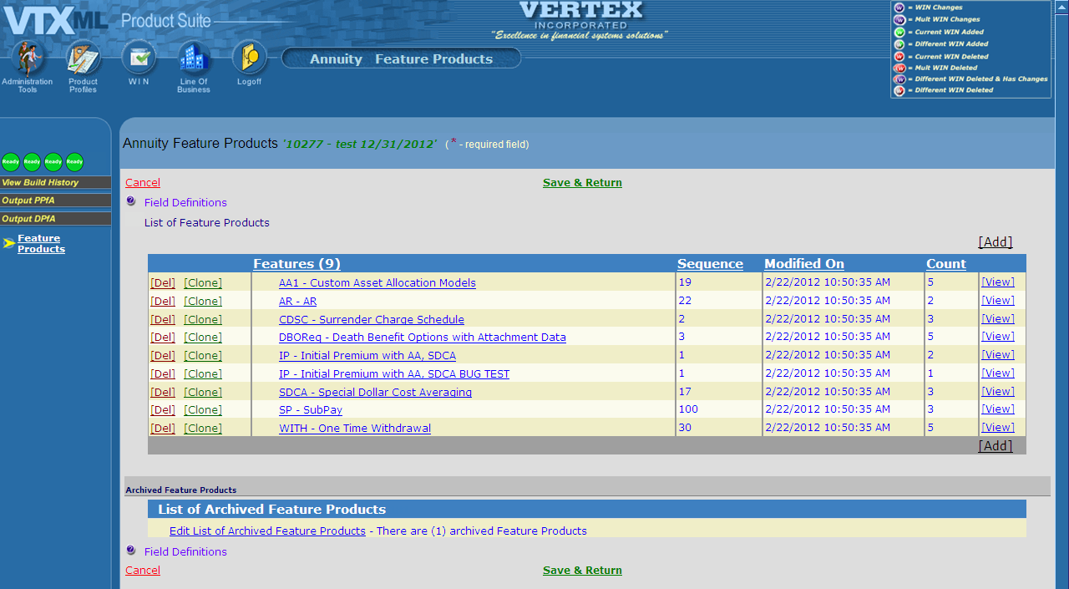

The Features work the same way they worked on the main Feature page. They can still be edited, deleted, cloned, added to any Product. The Features will still show up in output if attached to a Product. This popup allows the user to de-clutter the main Feature page and manage the older Features without interfering with the New Business Features.

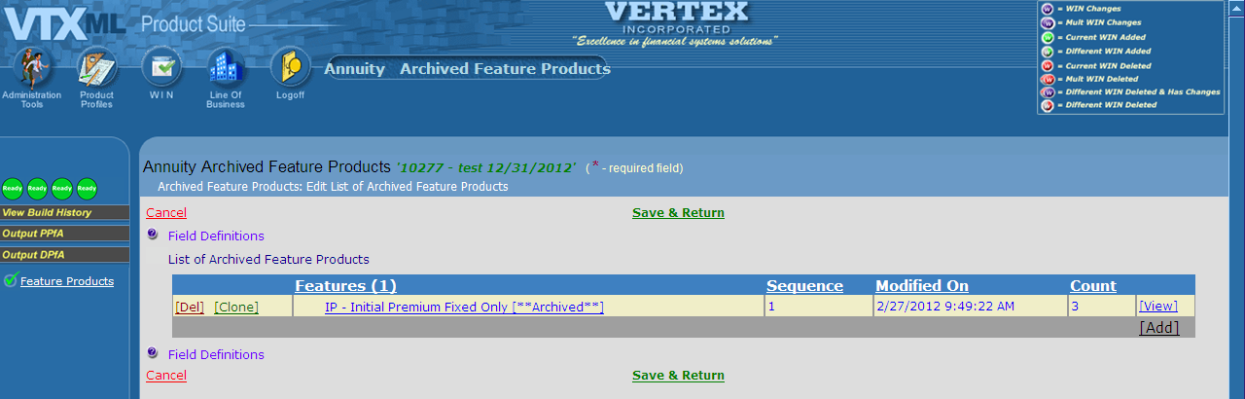

x) Field level display based on Carrier

VTXml now has the ability to hide specific fields by Carrier.

